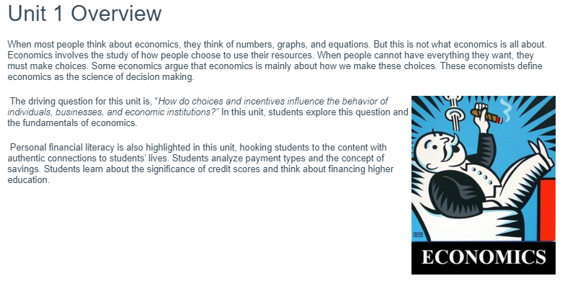
The Individual and the Economy

Learning Target #1
Watch this video: https://www.youtube.com/watch?v=yoVc_S_gd_0&feature=youtu.be
As you watch the video, look for answers to these questions:
- Describe scarcity

- Why is scarcity important in the study of economics?

- What is an example of scarcity in the real world? How do you know?
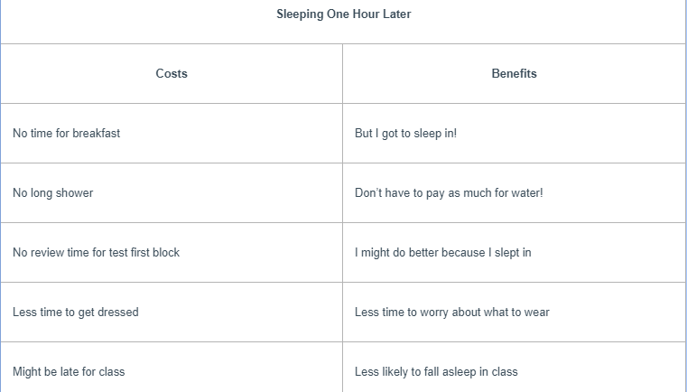
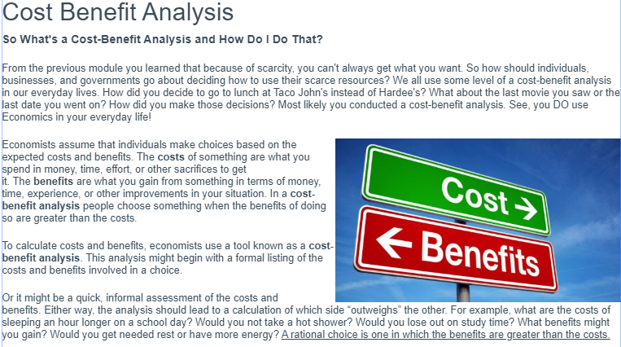
Think about how a cost-benefit analysis might come into play during a road trip. Each evening, you and your friend face the choice between pitching a tent at an inexpensive campground or paying more for a motel room with a soft bed and shower. Your decision would depend on your own analysis of the costs and benefits of each arrangement. The choice here is personal. Do the benefits of renting a motel room outweigh the higher cost? Each person’s decisions may be different based on what each individual values.

Cost Benefit analysis decision making
Scenario: It is Friday night. Your only chunk of free time all weekend is tonight from 6:00pm to 11:00pm. Before deciding how you will spend this time, consider these factors:
- You have $40 to spend
- You have an economics test on Monday (study time varies, $0)
- This is the last football game of the season (3 hours, $5)
- It is your mother’s birthday (family time varies, $0)
- Someone you like has asked you out on a date (2 hours, $20)
- Your favorite music group is in town tonight only (4 hours, $40)
- A movie you want to see is showing tonight (2 hours, $10)
- You could pick up extra hours at work (work hours vary, earn $10 per hour)

Task: Create a table similar to the one below to show how you plan to spend your time. AFTER you have made your decision for how to spend your time, answer the three questions below the table. Create your own activities or choose from the list of possible activities. If you choose an activity from the list, use the given time and price.

Time | Activity | Price
6:00pm
7:00pm
8:00pm
9:00pm
10:00pm
11:00pm

- What decisions did you have to make in this exercise?

- What constraints (limitations) did you face when making these decisions?

- For each decision you made about how to spend your time, what did you have to give up?

- Why were your decisions different than those of others?

Learning target 1 continued:
Opportunity cost
Part One: Watch this video: https://www.youtube.com/watch?v=NwOYLV-L7pc&feature=youtu.be then complete the activity below

Part two:
Look at your table from cost-benefit analysis and do the following:
Make a list ranking (most favorite to least favorite) all your choices of how you could have spent the 6pm hour of your Friday night (start with what you actually did and fill in the rest)

Circle your first choice
Put a square around the rest
Place a star next to option number two

Part three:
Label each part of your list with the appropriate bold term. #1 is decision, the choice that had the best benefits and outweighed the benefits of the other options that you placed a square around. ALL of the other options you did not choose are your trade-offs for the decision you made. Trade-offs are all the things you give up when you make a choice. #2 is your opportunity cost, the next best option of how you could have spent your time.

Is college worth the cost?

Many recent college graduates have faced record levels of unemployment. This situation has led people to question what they value about higher education. Some high school students and their parents are wondering if a college education is worth the cost. Others, however, believe that a college education prepares students for more than just a job or career.
Find at least 4 sources, then synthesize information from two – three of the sources and incorporate it into a coherent, well-developed essay that evaluates whether college is worth its cost.
Your argument should be the focus of your essay. Use the sources to develop your argument and explain the reasoning for it. Avoid merely summarizing the sources. Indicate clearly using MLA format in-text citations which sources you are drawing from when you use them for evidence. You may use direct quotation, paraphrase, or short summary of the sources. You may cite the sources using the author’s last name or title.

Your essay should include an introduction, body, and conclusion:
Introduction Paragraph: 4-5 sentences that include: hook sentence, background information, and the thesis. The thesis must identify two clear, logical reasons based on the source information of whether college is worth the cost or whether college is not worth the cost.
Body Paragraph: 8 sentences that include:
Sentence 1: Topic Sentence (your claim about whether college is worth the cost with two reasons why it is or isn’t worth the cost.
Sentence 2: STATEMENT: Major Support Statement #1 (the first reason why college is/isn’t worth the cost)
Sentence 3: EXAMPLE: Fact, detail, or reference from document(s) that backs up Major Support Statement #1 (evidence from provided document)
Sentence 4: ANALYSIS: Student commentary that justifies previous sentence (explain why the evidence you provided is proof of the reason provided that college is/isn’t worth the cost)
Sentence 5: STATEMENT: Major Support Statement #2 (the second reason why college is/isn’t worth the cost)
Sentence 6: EXAMPLE: Fact, detail, or reference from document(s) that backs up Major Support Statement (evidence from provided document)
Sentence 7: ANALYSIS: Student commentary that justifies previous sentence (explain why the evidence you provided is proof of the reason provided that college is/isn’t worth the cost)
Sentence 8: Closing Sentence (this is a transition sentence to your conclusion)
Conclusion Paragraph: 3-4 sentences that include: restatement of key ideas and concluding sentence.
Learning Target #2
Different Types of Credit (Loans)
The readings on the next few pages go over the three main types of widely used credit options; bank loans, credit cards, and payday loans. Each has its own positives and negatives. While reading the pages, it may be helpful to create an organizer like the one below. These will be the things you will need to know in order to evaluate different scenarios and which credit option to use.

Credit Options | Description | Reasons to use | Reasons to avoid
Bank Loan

Credit Card

Payday Loan

Loan Types - Bank Loans
EVERYTHING YOU NEED TO KNOW ABOUT LOANS
A loan is a sum of money borrowed from the bank to assist for certain planned or unplanned events. The borrower is required to pay back the loan, including the interest charged over a stipulated period. There are several types of loans for various financial requirements.
TYPES OF LOANS
Banks provide various types of loans to ensure that they meet all your needs.
- Home Loan – The bank borrows you money, and the house remains the property of the bank until the final instalment is made. Consumers are required to pay back the loan on a monthly basis, at the given interest rate and over a stipulated period, normally 20yrs.
- Student Loan – Students that want to further their studies at any higher education institution that require financial assistance apply for student loans. The bank provides the money for the duration of their studies and after the completion of their studies; the student needs to pay back the money. The interest rates are usually low and there are flexible repayment options.
- Car Loan – Most banks provide car loans for both used and new cars. Consumers pay back the instalments on a monthly basis, and the vehicle belongs to the bank until the final payment is made.
- Personal Loan – Banks provide different options when it comes to a personal loan. This is a financial solution ideal to suit all your needs. The amount of money that you can borrow depends on the chosen bank, your financial eligibility and affordability to repay the loan.
- Business Loan – A business loan provides you with the capital to start your business venture. The bank provides you with the money and you are required to make the repayments after an agreed period of time. The requirements vary according to each bank and whether you are a new business or have been in operation plays a major part in your loan application.
FACTORS TO CONSIDER
Taking a loan is a big responsibility and you are required to pay back all the money plus interest. There are numerous factors that will affect the cost of your loan, namely:
- Credit Record – Your credit record will determine your loan rates. If your credit record is good and shows reliability, you will incur lower interest rates. Similarly, if your credit record is in a bad state, it will be more difficult for you to obtain a loan, and your interest rates will be higher.
- Loan Duration – The loan duration is another factor when deciding on the cost of your loan. The longer you choose to pay off your loan, the higher the interest rates.
- Type of Loan - The type of loan you decide on will also impact your interest rates, a secured loan, usually contains lower rates, compared to an unsecured loan.
- Inflation Rate – The inflation rate is the rate at which prices increase in the economy. This has a major impact on your interest rates.
When you take out a loan, it is imperative to know your repayment date. If you have not signed a stop order it is your responsibility to ensure that the monthly payments are made on the due date for the duration of the loan period. If you fail to repay the correct amount, there are numerous penalties you may face, including:
- A bad credit record
- A higher interest rate
- Reduced chances of applying for another loan
- An additional late payment fee

Loan Types - Credit Cards
Below are resources to fill in the Credit Cards section of the graphic organizer you have for Types of Credit.
Resource #1: Video
Directions: Watch the video below to help you fill in your organizer. If you need another resource to complete the organizer, use the reading below.
https://www.youtube.com/watch?v=Yy1OxM_18EQ&feature=youtu.be

Resource #2: Reading
Directions: If you prefer to use a reading to help you fill in the organizer or felt you needed more information, use the reading below to help you fill in the necessary information.
Reading: Credit Cards
Using a credit card really means you are taking out a loan. When you buy something on a credit card, you promise to pay back the charges on your account plus a payment for interest and fees. Credit card loans are revolving credit plans. You have access to a fixed amount of money, called your credit limit. Once you repay any of the money you have spent, you can borrow that amount all over again. A statement is mailed or sent online to the card holder each month showing the charges, the total owed, the minimum to pay, and the finance charge.
Many institutions put their names on credit cards, including banks, department stores, airline companies, savings and loan companies, credit unions, oil companies, finance companies, automobile companies, telephone companies, and even national football and baseball teams.
Most credit card companies charge a fixed interest rate. Many charge an annual fee for the card. Most credit cards offer a grace period (usually 30 days) that allows you to avoid paying interest on the balance if the balance is paid in full.
Here is an example: What you borrow, or what you spend, is called the principal. For the privilege of using the principal, you pay the credit card issuer a finance charge, which is the interest that accumulates on any unpaid balance. If you have a balance of $600 on a card with an annual interest rate of 18 percent, your monthly finance charge will be $9. It is calculated by multiplying a month’s worth of interest—1.5 percent—times the balance. Every credit card company has to disclose the interest rate it charges on the balance you carry, and different cards charge different rates so it’s worth shopping around.

Here are some tips for using a credit card successfully:
- Have only two or three cards.
- Pay off the total balance due each month.
- Shop for a card with a low interest rate.
- Shop for a card with no annual fee, or a low fee.
- Use your card for such things as travel and emergency purchases.
- Use credit card statements to keep track of spending.
- Notify the credit card issuer immediately if the card is lost or stolen.
- Never give your credit card numbers or expiration dates to businesses you do not know, whether it is by phone or online.
- Notify your card issuer if you will be traveling out of the country.
- Report any questionable charges to the card issuer.
- Keep an eye on your card when using it for a transaction. Make sure you get it back when you leave.

Loan Types - Payday Loans
Use the reading below to fill in the Payday Loans section of the organizer.
Reading - Payday Loans
In addition to mainstream financial services, there are alternative forms of credit. No doubt you have noticed that in nearly every strip mall in America—small towns and large urban centers alike—there are stores offering financial services such as check cashing, payday loans, pawn shops, and rent-to-own items.
Many individuals have discovered advantages in using alternative financial services. Here are three reasons why: First, these outlets offer financial services that people find useful. Many banks, for example, do not offer short-term loans for small amounts of cash. And people often find it convenient to use check-cashing services, money orders, and wire transfers. Second, the outlets that offer these services tend to be conveniently located. In some neighborhoods there are more check-cashing outlets than grocery stores. Obviously, these outlets are responding to demand in local communities for the services they provide. Third, these outlets provide quick services with a minimum of hassle. Cash may be provided quickly, with few questions asked and few papers to sign.
There are several disadvantages, however, to using alternative financial services. Payday loans provide an example. Payday loans are small loans made by a short-term lender to individuals—usually for $300 to $500. The key advantage is that such loans may be helpful to people facing a short-term financial emergency—an unexpected moving expense, a medical expense, a car repair bill, and so forth. While banks often do not offer loans for less than $1,000, short-term lenders do.
These loans are usually very expensive. Let’s consider their costs from a couple of different angles. Suppose the fee for a two-week $100 loan is $33. If you convert that fee to an annual percentage rate, it comes to 858 percent. That is a terribly high rate. Think of the opportunity costs of taking out such a loan—all the other things that could be done with the money that is instead paid as interest.
The annual percentage rate may not mean much to some, so let’s consider the cost in another way. The main disadvantage of payday loans is that many people do not pay them back on time. If a person is a little short of cash before the end of one pay period, it is easy to imagine that he or she will be short of cash during the next pay period. When the borrower cannot pay off the loan, the loan is renewed or “rolled over.” This means taking out another loan to pay off the first loan. Or the loan agreement may specify that an interest payment will be required to extend the first loan if it is not paid off on time. Either way, it is expensive. Imagine that a person takes out a payday loan for $200 for two weeks at a fee of $40.00. If this loan is refinanced four times, the cost increases dramatically. In fact, in the course of four renewals, the borrower will wind up paying approximately $400 ($200 in interest) to borrow $200 for just 10 weeks.
Mainstream financial institutions such as retail banks, savings and loan associations, and credit unions offer many advantages over the check-cashing outlets and providers of payday loans. Most importantly, banks offer a safe place to keep money. The federal government insures deposits in banks. In contrast, holding cash savings at home is very risky. Cash can be easily lost or stolen. Banks and similar institutions offer several other advantages as well. They enable bank customers to accumulate savings, develop a credit history, keep records, and use various financial services at comparatively low rates. It makes sense to deal with mainstream financial institutions as your individual situation permits.

Video: https://www.youtube.com/watch?v=3rOVmUnUM7A&feature=youtu.be

Credit Scenarios Practice
Directions: This activity provides you with an opportunity to practice two credit scenarios to prepare for your Learning Target #2 Assessment. After you post your own response to the two scenarios, be sure to review the posts of others to double check your own thinking. Feel free to like the solutions of other students.
Scenario #1:
James’ car breaks down and the mechanic tells him that it will cost $1,500 to fix his cracked radiator. The only problem is that James won’t have enough money until 2 weeks from now when he gets his next paycheck.
- What are the costs (negatives) and benefits (positives) of the different credit options James has?

- Which option should James choose? Why?

Scenario #2:
James has been promoted at work and needs to buy a suit for his new role as “Director of Clown College”. The suit retails for $200, but James won’t have the money from his new job until his paperwork clears a month from now. How should James get the money for his new suit?
- What are the costs (negatives) and benefits (positives) of the different credit options James has?

- Which option should James choose? Why?

Learning Target 2 Assessment: Justify the use of possible credit options when
making different financial decisions.

This needs to be completed in a paper, PowerPoint, Weebly, etc.

Scenario 1
Layla purchased a new $8,000 car using her Capital One Visa (credit card). In the space provided
below, explain if this is a good or bad choice using the success criteria in order to meet the learning target.

You must:
- Describe different credit options based on this scenario (the one from the scenario and the one she should have chosen
- Evaluate the different credit options you described
- Justify which credit option is best for this decision

Scenario 2:
Cooper got a pay day loan to cover his $450 rent this month. In the space provided below, explain if this is a good or bad choice using the success criteria in order to meet the learning target.

You must:
- Describe different credit options based on this scenario (The one from the scenario and the one he should choose).
- Evaluate the different credit options you described
- Justify which credit option is best for this decision

