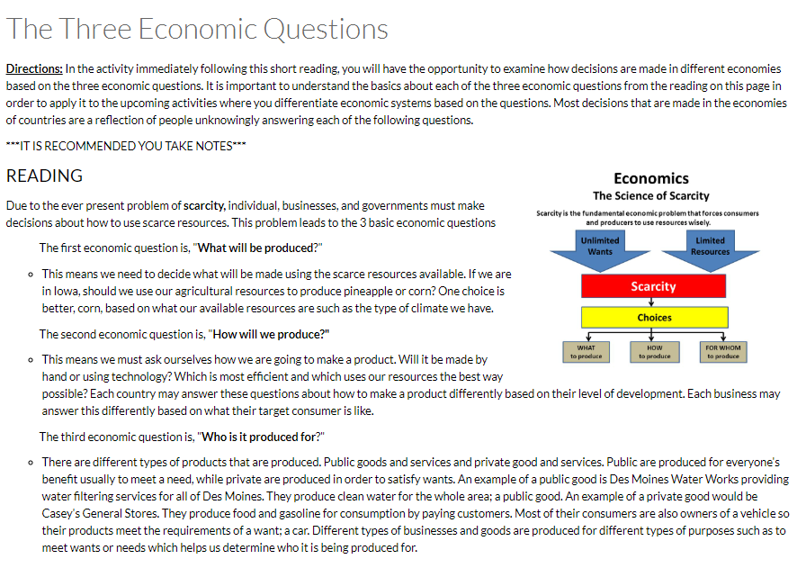
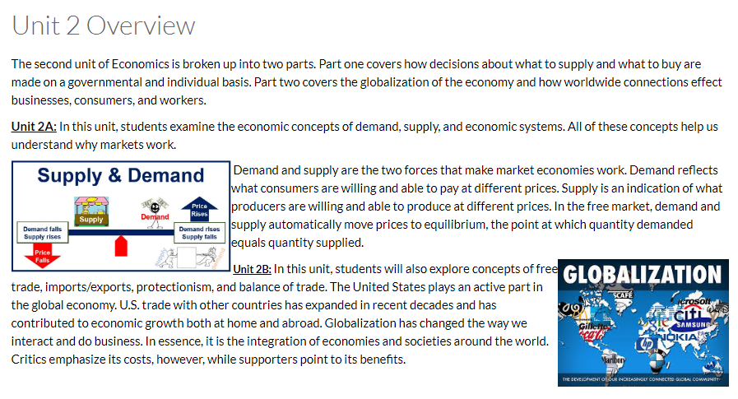
How markets work

Directions: Identify the economic question in each scenario.
- Canada passes a law providing free medical care for all its citizens.
  - For whom will it be produced?
  - What will be produced?
  - How will it be produced?

- Farmers decide to double their wheat crops while cutting back slightly on their soybeans.
  - How will it be produced?
  - What will be produced?
  - For whom will it be produced?

- Nabisco replaces assembly line workers with robots at its plant.
  - How will it be produced?
  - What will be produced?
  - For whom will it be produced?

Economic systems reading
Directions: Complete the readings on the next few pages. Highlight and take notes to gather information on how and why different economic systems form. You will use this information to answer questions later in this packet.

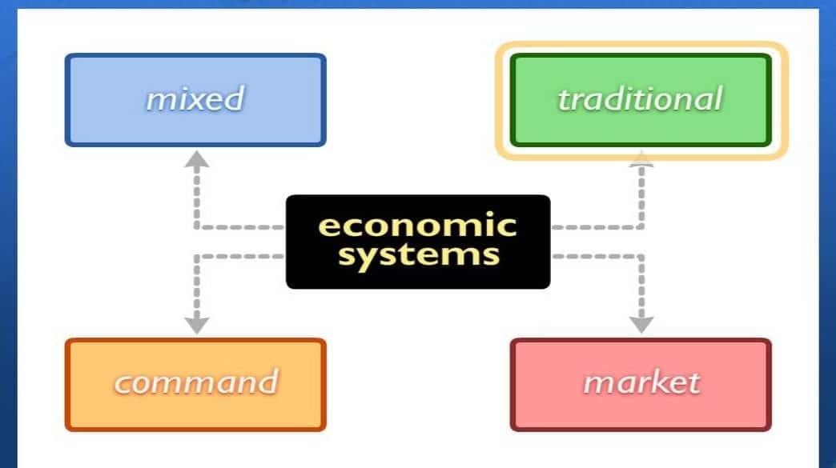

Take Notes Over the Following:
- How does each economic system answer the three economic questions?
- How does each economic system affect businesses?
- How does each economic system affect individuals?
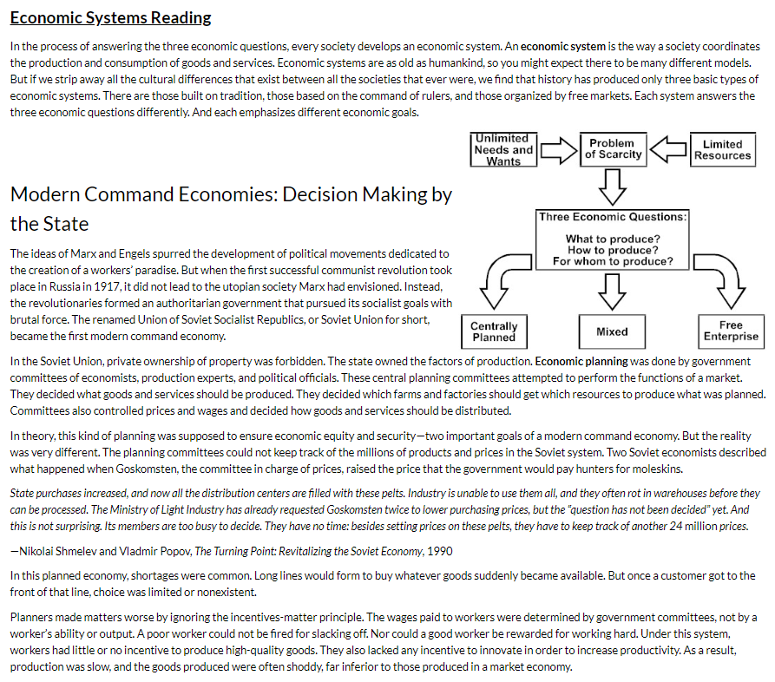
NOTES:

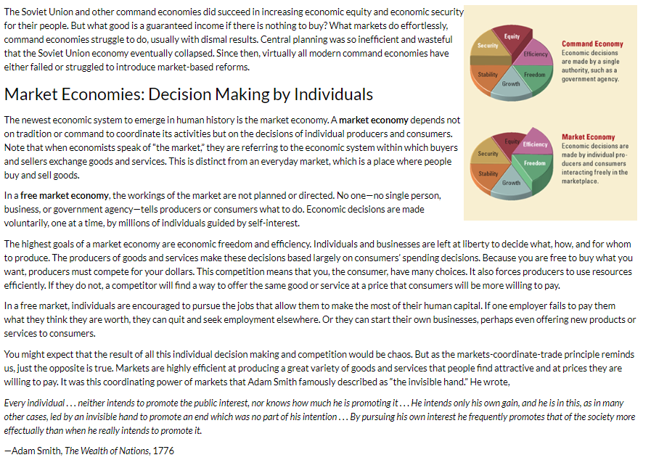
NOTES:

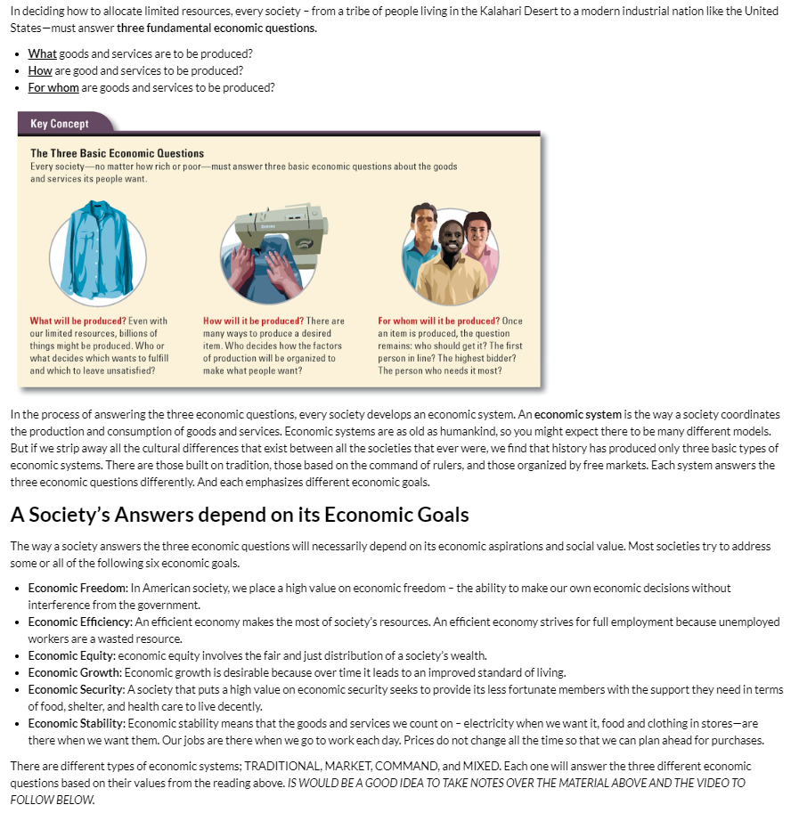
Economic Systems Continued
NOTES:

Video:
In the video below, pay attention to how each type of economic system from the video (Market and Command) decides, What to Produce, How to Produce, and For Whom to Produce.
https://www.youtube.com/watch?v=Ve6K10-Yx_M

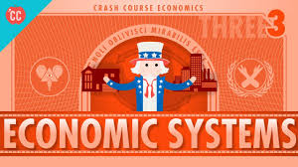

Directions: Pick TWO of the scenarios to answer.
Option A: Farmer – Flooding has destroyed half of your crops. Because of the timing you don’t have time to replant and will not be able to cover your expenses for the year.
- How would this person be affected in a Market Economy? (include costs and benefits)
- How would this person be affected in a Command Economy? (Include costs and benefits)

Option B: Factor Worker – You have worked at your job for 10 years and your production is double that of your coworkers.
- How would this person be affected in a Market Economy? (include costs and benefits)
- How would this person be affected in a Command Economy? (Include costs and benefits)

Option C: Single Parent with Two Children – You are a single mother who is the sole provider for your two children and have recently lost your job.
- How would this person be affected in a Market Economy? (include costs and benefits)
- How would this person be affected in a Command Economy? (Include costs and benefits)

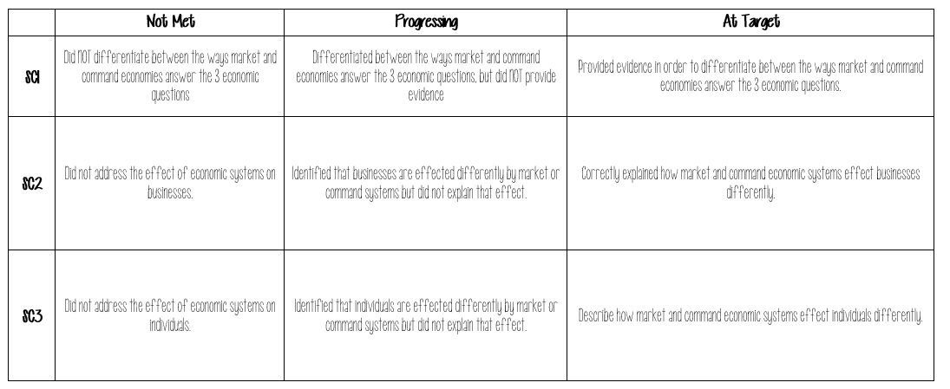
evaluate the role of government in different economic systems

Directions: Using the scenarios of countries listed below, respond to each question based on the type of economic system each country is.

In Hooverland the government controls all the resources | In North Islands the government has no control of the resources
Which type of economic system is Hooverland? | Which type of economic system are the North Islands?
Describe how this economic system answer the 3 economic questions | Describe how this economic system answers the 3 economic questions
Describe how this economic system effects businesses AND individuals | Describe how this economic system effects businesses AND individuals

In 2-3 paragraphs, tell me which economic system is better AND why?

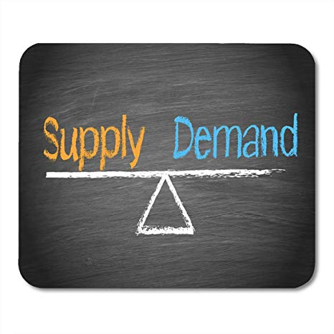

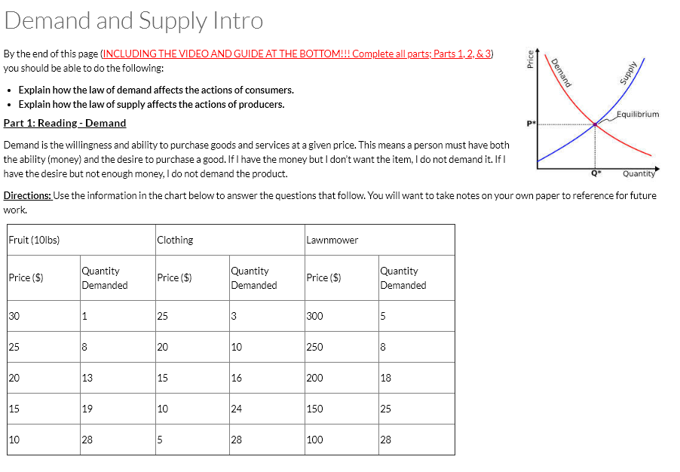

- Look at the number above for Price and Quantity, how are they related?

- This relationship you identified above is called the LAW of DEMAD. Explain how high prices might affect the behavior of consumers.

Watch the video: https://www.youtube.com/watch?v=g9aDizJpd_s

- Explain how the Law of Demand affects the behavior of consumers.

- Explain how the Law of Supply affects the behavior of producers

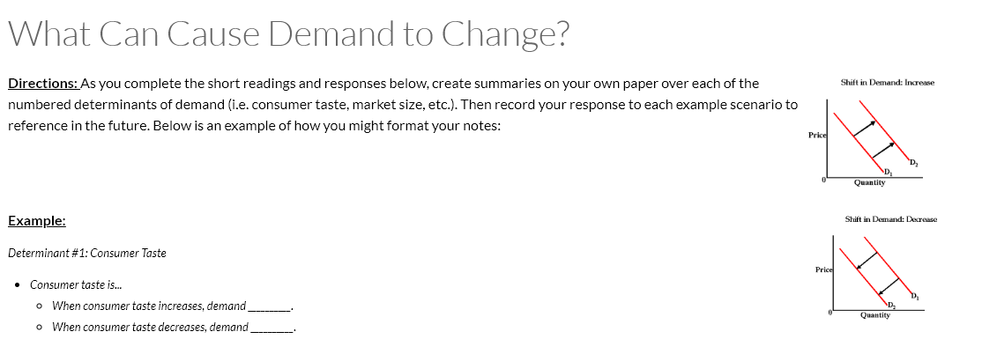
Reading: Determinants of Demand
The determinants of demand of a particular good, service or commodity refer to all the factors that determine the quantity demanded of an individual or household for the particular commodity.
- Consumer Tastes (popularity): The tastes and preferences of the individual or household.

Effect on Demand: As taste turns in favor of a product the demand increases, as taste turns against a product the demand will decrease.

Example: Beyoncé shoots a commercial for Pepsi this will increase the popularity of Pepsi due to her popularity

How will this effect demand for Pepsi?

- Substitute Goods: The price of a good that can be used in place of another. These are goods whose consumption can replace the consumption of the given item. The cheaper the substitute good, the less the demand for the other good. This is the substitution effect.

Effects on Demand: As the cost of product 1 is decreased, the demand for its substitute will decrease. As the cost of product 1 is increased the demand for its substitute will increase

Example: Tasty-Os are on sale for $2.00 and Cheerios cost $4.50.

How will this effect demand for Cheerios?

- Complementary Goods: The price of a good used WITH another one is a complementary good. When items are complementary, and we buy one item we typically buy another thing that goes with it.

Effect on Demand: As the cost of product 1 is decreased, the demand for its complement will increase. As the cost of product 1 is increased the demand for its complement will decrease.

Example: Hot dogs are on sale for $1.25 and the cost of hot dog buns remain unchanged at $3.00.

How will this effect demand for hot dog buns?

- Income: the disposable income that the household has. More specifically, the amount of household income that it is generally willing to spend on non-necessary products.
Effects on Demand: An increase in income leads to an increase in demand for most goods, while a decrease in income leads to a decrease in demand for most goods. This is termed the income effect.
Example: GMC lays off 25,000 employees nationwide.
How will this effect demand?

- Consumer Expectations (of future prices): How people’s purchasing behavior changes today as a result of expected price changes in the future. This is particularly important for goods that there is no urgency/immediate need to purchase.

Effect on Demand: If future prices are expected to be lower, demand is less for the current price, because a person decides to delay the purchase until later when the price is lower. If future prices are expected to be higher, demand is higher for the current price, because a person prefers to buy now before the good becomes too expensive.

Example: Best Buy releases their Black Friday ad.

How will this effect demand for Best Buy products?

- Market Size: The amount of customers in a market.

Effect on Demand: As the amount of customers increases, demand increases. This happens because there are more people willing to purchase items. As the amount of customers decreases, demand decreases. This happens because there are less people willing to purchase items.

Example: It’s raining at a baseball game.

How will this effect demand for peanuts?

Video: Use the video to review the notes you took above. Some vocabulary words may be different. https://www.youtube.com/watch?v=LwLh6ax0zTE

Directions: For each of the demand scenarios below, do the following on the chart (next page):
- Record the scenario in the first row

- Draw what will likely happen to the demand curve based on the scenario. (shift right for more demand, left for less demand)

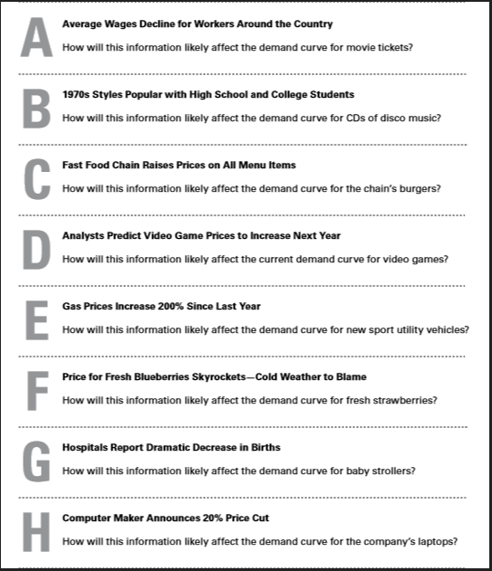
- Explain your graph. In the explanation, cite the demand determinant from your notes. There is one scenario that will not shift demand, it instead is just a change in price of the item.

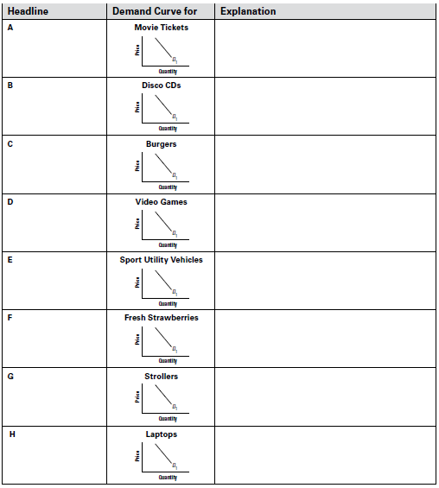

Demand determinants check in

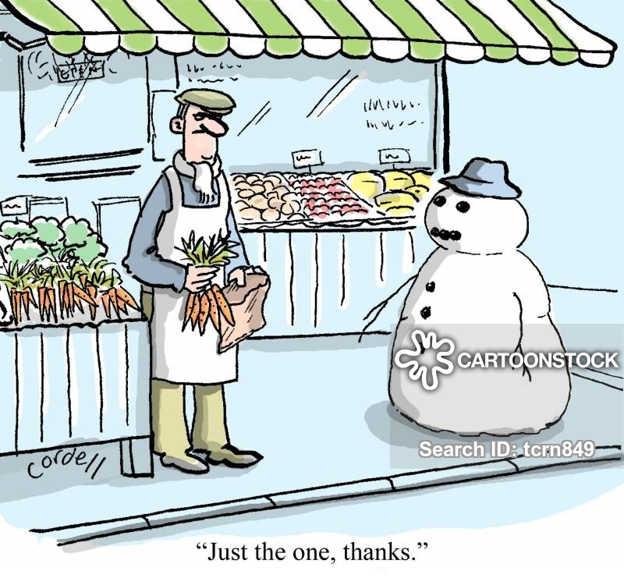

- Create a scenario that increases demand. You may not use any from the previous activity.
  - Then, Identify the determinant used in your scenario and explain why the determinant increased demand.

- Create a scenario that decreases demand. You may not use any from the previous activity.
  - Then, identify the determinant used in your scenario and explain why the determinant decreased demand

What causes supply to change?
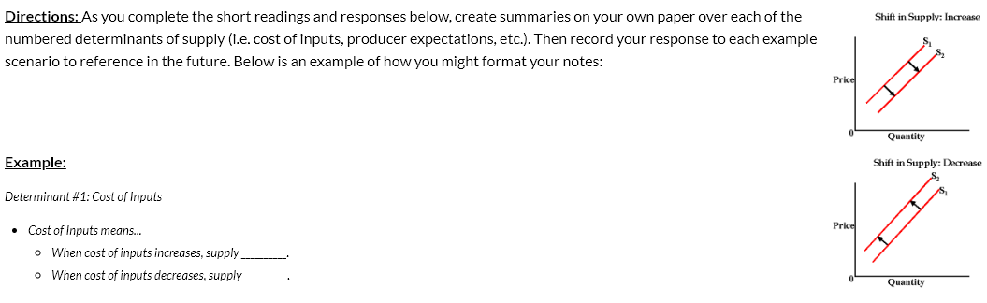
LAW OF SUPPLY: As price goes up, quantity supplied goes up. As price goes down, quantity supplied goes down.

Determinants of Supply Reading
The determinants of supply of a particular good, service, or commodity refer to all of the factors that determine the quantity supplied of an individual or household for the particular commodity.

- Cost of Inputs: The cost of an input product. Input products include the land, labor, and capital required to produce the good or service.

Effects on Supply: As the cost of an input increases, the supply for the final good decreases since producers will not want to pay the extra cost for the input. As the cost of an input decreases, the supply for the final good increases since the producer will want to supply more of the final good since it has gotten cheaper to produce.

Example: The cost of peanuts has increases.

How will this effect supply for peanut butter?

- Technology: All the methods people can use to turn inputs into useful goods and services.
Effects on Supply: As technology improves (increases), the cost of producing the product decreases and therefore producers want to produce more and the supply increase. TECHNOLOGY WILL NEVER DECREASE (unless there’s a zombie apocalypse or Armageddon, but at that point who cares about supply and demand).
Examples: New robots have been developed which produce cars twice as fast as humans.
How will this effect supply for cars?

- Number of Producers: The number of manufacturers producing any given product.

Effect on Supply: As the number of producers increases supply will also increase, while the number of producers decreases the supply of the product will also decrease.

Example: Tasty Tacos moves into an empty building across from Lincoln, near Henry J’s Tacos and Taco Johns.

How will this effect supply for Tacos on the Southside near Lincoln?

- Producers Expectations (of future prices): how producers behavior changes today as a result of expected price changes in the future.
Effect on Supply: If future prices are expected to be lower, supply is more for the current price, because a producer can make more money selling the product today than if they wait until the price goes down in the future. If future prices are expected to be higher, supply is less for the current price, because a producer believes they will make more money selling the product in the future and thus will supply very little today.
Example: The cost of gas is expected to increase dramatically over the next 2 weeks.
How will this effect supply for gas today?

- Excise Tax: A tax applied by the government on certain products they wish to discourage the use of like cigarettes, alcohol, and gasoline.

Effect on Supply: As the excise tax is increased on a product the supply will decrease because the producer will be making less in profit. If the excise tax is decreased the supply will increase because the producer can make more of a profit.

Example: The cigarette tax has been increased by $0.25.

How will this effect supply for cigarettes?

6. Subsidy: The opposite of a tax, a subsidy is when the government provides an extra payment to producers of certain goods and services that they see as being beneficial.

Effect on Supply: As the government increases or provides a subsidy supply will increase because producers will make more profit. As the government decreases or takes away a subsidy supply will decrease because producers will make less profit.

Example: The US government provides a subsidy for solar powered cars.

How will this effect supply for solar powered vehicles?

Video: Use this video to review the determinants you took notes on from the previous pages. https://www.youtube.com/watch?v=ewPNugIqCUM

Directions: For each of the supply scenarios do the following on the chart (next page)
- Record the scenario in the first row

- Draw what will likely happen to the supply curve based on the scenario (shift right for more supply, left for less supply)

- Explain your graph. In the explanation, cite the SUPPLY determinant from your notes. There is one scenario that will not shift supply, instead is just a change in price.
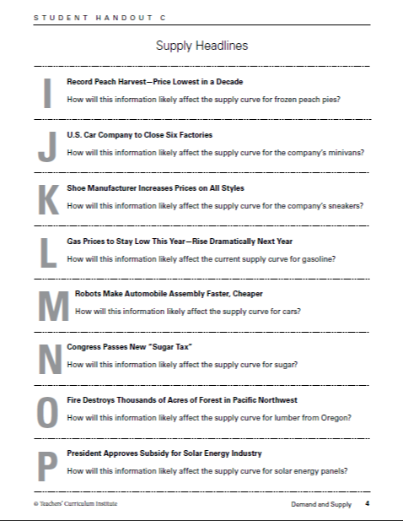

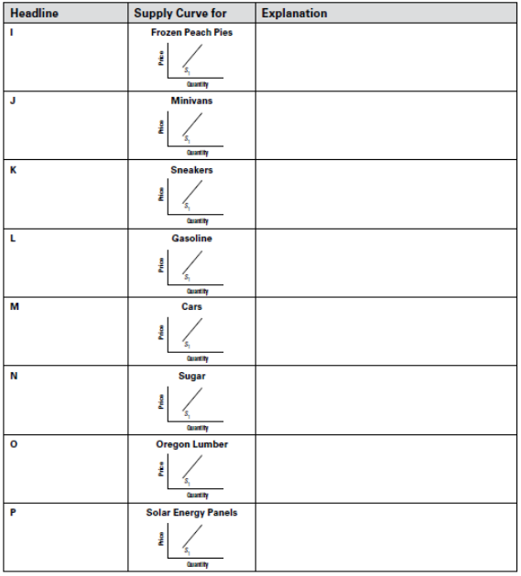

Supply determinants check in
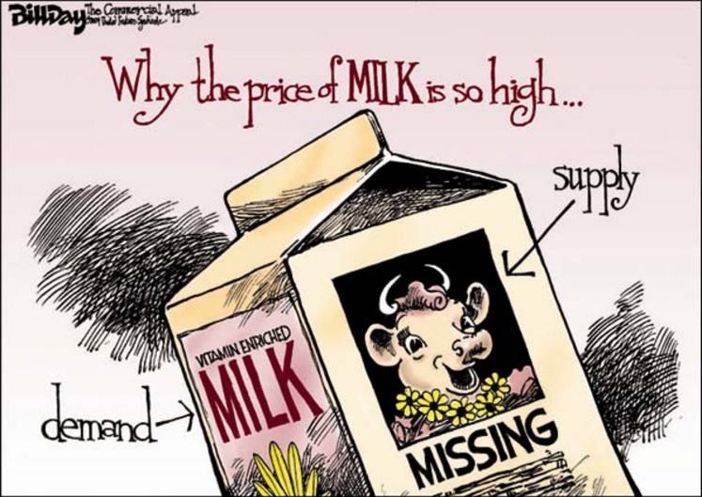

- Create a scenario that increases SUPPLY. You may not use any from the previous activity.
  - Then, Identify the determinant used in your scenario and Explain why the determinant increased SUPPLY.

- Create a scenario that decreases SUPPY. You may not use any from the previous activity.
  - Then, Identify the determinant used in your scenario and Explain why the determinant decreased SUPPLY.

What happens when demand meets supply?

After completing this reading, you will participate in a discussion over the following question,
"What happens at the point where buyers and sellers agree? Use these terms in your answer: market equilibrium, equilibrium price, equilibrium quantity."
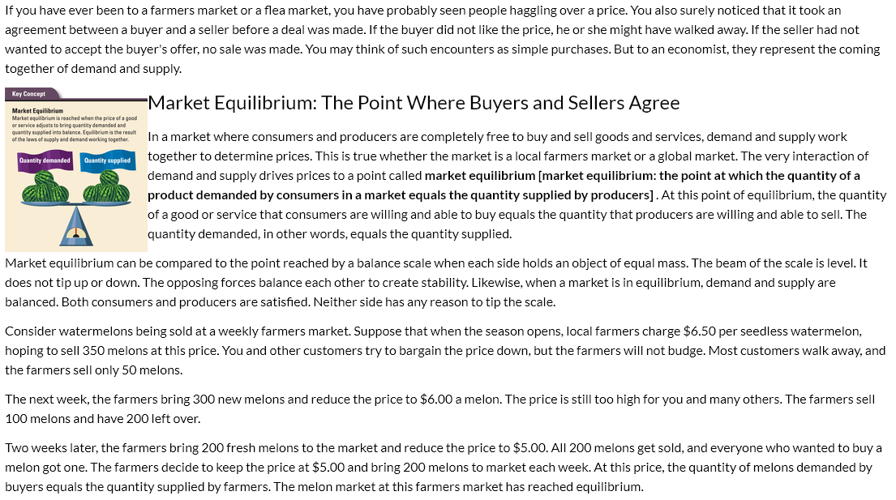

NOTES:
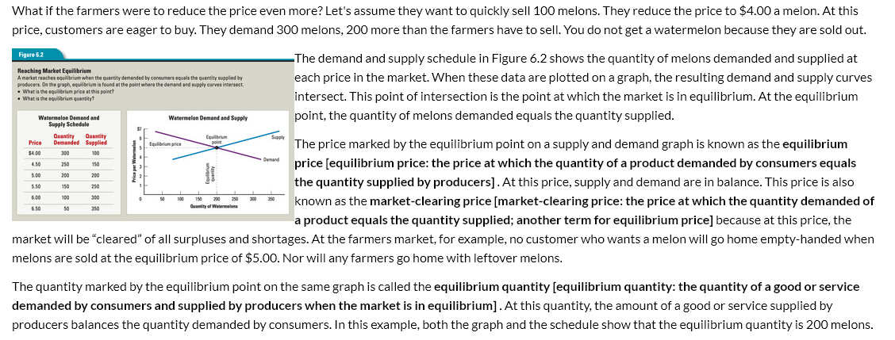
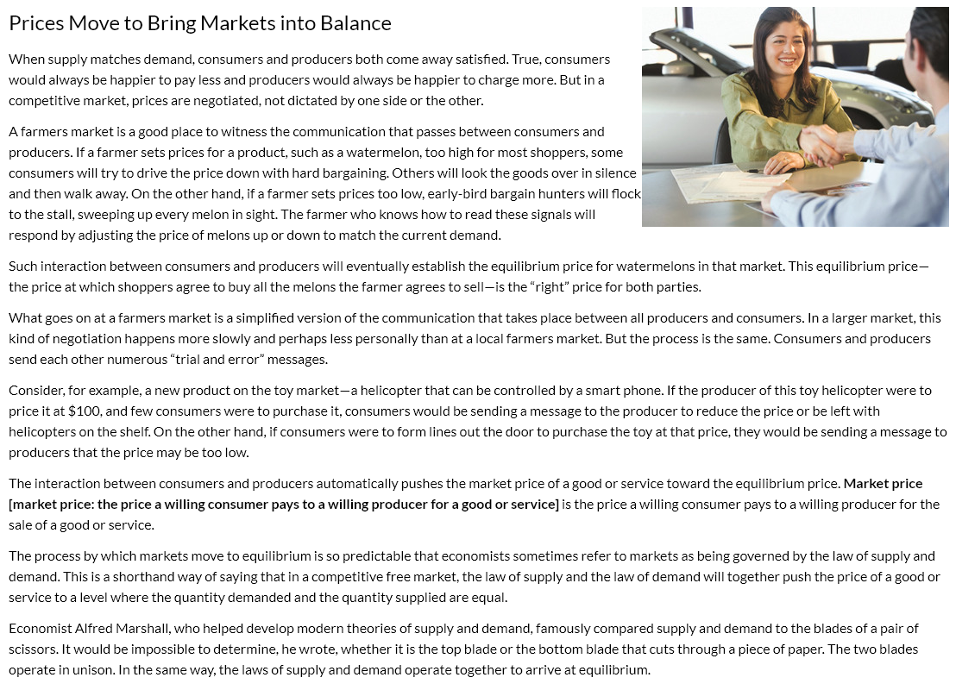
NOTES:
Equilibrium
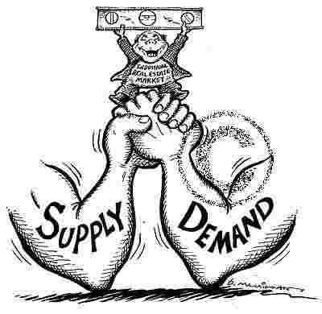

- Describe equilibrium

- Why/how does it affect producers and consumers?

Watch this video to participate in the next discussion: https://www.youtube.com/watch?v=V0tIOqU7m-c
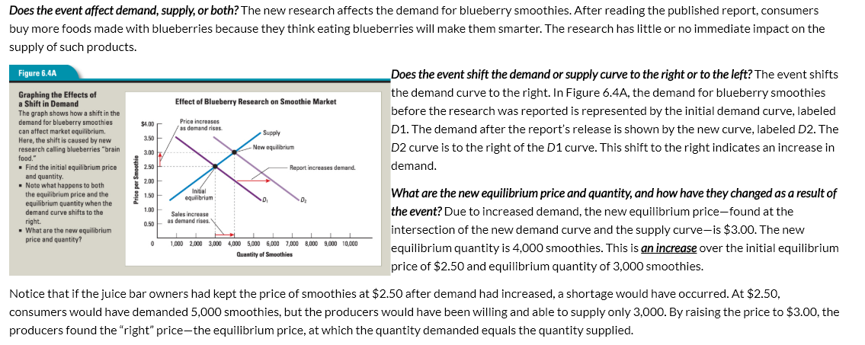
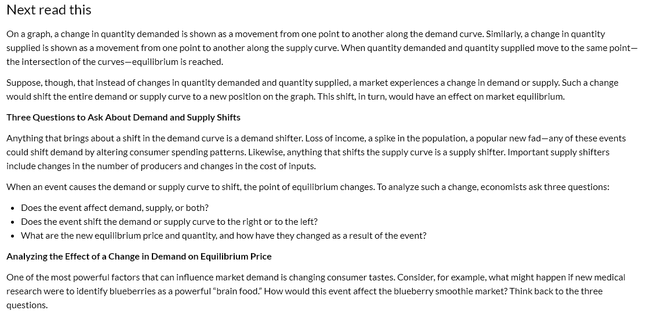
NOTES:

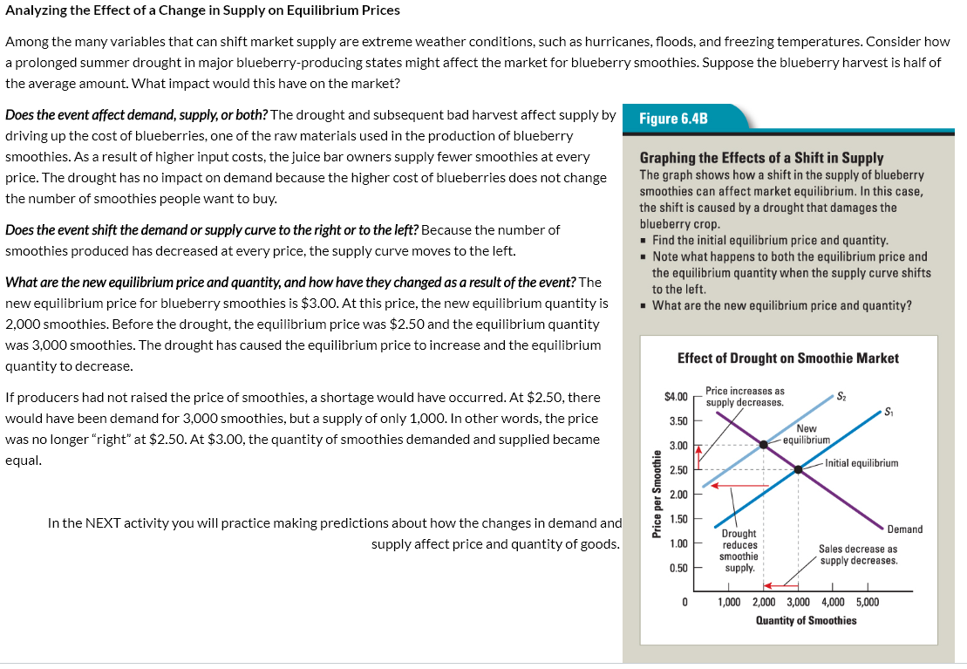
NOTES:

Directions: You will choose TWO of the scenarios from the four available below to analyze.
In your post, include responses to all of the following for the TWO scenarios you choose:
- Will this scenario affect the DEMAND or SUPPLY of sneakers?
- Will it increase or decrease the demand or supply (just one or the other)?
- Describe which of the determinants of demand or supply effected it.
- Identify what happened to price and quantity because of that change.
***It may be helpful to graph out the change on your own scratch paper if you like visuals.***

Scenario #1: New movie increases popularity of athletic shoes.
Scenario #2: Price of rubber increases dramatically.
Scenario #3: Two new athletic shoe companies open up.
Scenario #4: Consumers worry price of athletic shoes will increase next month.

LT #4 “Quiz”

- Explain how the law of demand affects the actions of consumers.

- Explain how the law of supply affects the actions of producers.

- Explain the importance of equilibrium.

- Complete each of the following for the determinant below:
Determinant = INPUT COSTS
  - Create a scenario that affects the determinant above.

  - Identify if demand or supply is affected.

  - Identify if demand or supply increased or decreased.

  - Describe how the change affected price and quantity of your product.

- Complete each of the following for the determinant below:
Determinant = Government Interventions (Excise Taxes OR Government Spending/Subsidies)
- Create a scenario that affects the determinant above.

- Identify if demand or supply is affected.

- Identify if demand or supply increased or decreased.

- Describe how the change affected price and quantity of your product.

- Directions: Complete each of the following for the determinant below.
Determinant = INCOME
- Create a scenario that affects the determinant above.

- Identify if demand or supply is affected.

- Identify if demand or supply increased or decreased.

- Describe how the change affected price and quantity of your product.

What happens when the price isn’t “right”
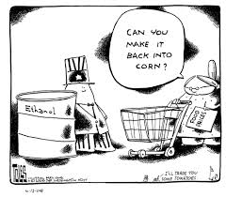

Directions: Watch the video, then answer the question below

https://www.youtube.com/watch?v=Zl4fmEoyyw4

Contrast how surpluses and shortages occur. Provide an example for each to support your thinking. Use an example that is all your own.

How does government intervention affect markets?

Directions: Watch the video then answer the questions below

https://www.youtube.com/watch?v=1EzY4Vl460U

What is a price ceiling and why is it used?

What type of problem could a price ceiling cause and why does that happen?

What is a price floor and why is it used?

What type of problem could a price floor cause and why does that happen?

Do you believe the positive effects of price ceilings and floor are worth the negative effects? Why or why not?

