Make sure you have completed the graphic organizer and watched the video before moving on.
https://www.youtube.com/watch?v=xPD477FuqtY

- Describe the process of globalization (be sure to use the terms multinational corporations and outsourcing)

Globalization in more developed countries

Directions: Use the chart below to help you respond to the scenarios on the next page. Each of the scenarios are from the perspective of MORE developed countries (ex: United States). You will choose ONE scenario to respond to on the next page.
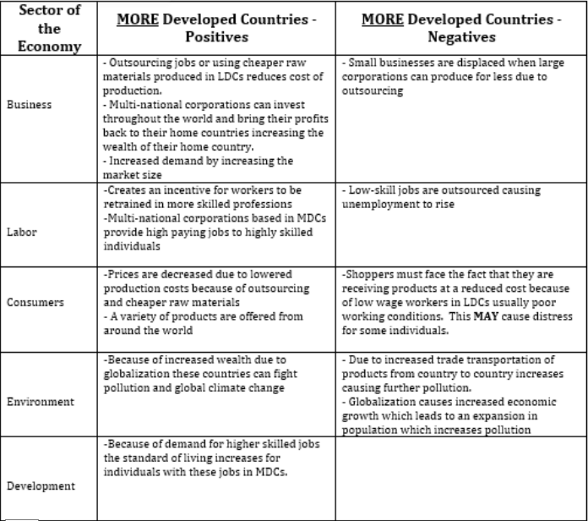

Scenario #1: Since the 1990s many businesses have moved their manufacturing centers overseas. Describe the positive and negative consequences this will have in MDCs like the United States.
a. Which aspects of the economy (from the chart) will this affect? List ALL affected.
b. Describe the positive and negative effects on those aspects for the economies of MDCs like the United States.
Scenario #2: Many corporations have now become multinational corporations. Describe the positive and negative consequences this will have in places like the United States ONLY.
a. Which aspects of the economy (from the chart) will this affect? List ALL affected.
b. Describe the positive and negative effects on those aspects for the economies of MDCs like the United States.

***** I do not want you to simply copy down the information in the table. You need to think about how the positive/negative effect on one aspect may cause an effect on another. The goal is to show the connection between the different aspects of the economy, explaining how they happened. *****

Globalization in less developed countries

Directions: Use the chart below to help you respond to the scenarios on the next page. Each scenario is from the perspective of LESS developed countries (ex: Vietnam). You will post your response to ONE of the scenarios on the next page.

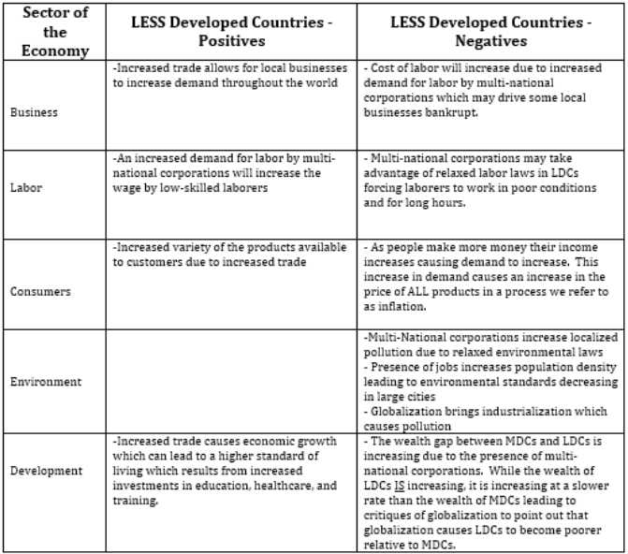
Scenario #1: Due to globalization, Singapore is now one of the top biotechnology research locations in the world. Describe the positive and negative consequences this will have in developing countries ONLY.
a. Which aspects of the economy (from the chart) will this affect? List ALL affected.
b. Describe the positive and negative effects on those aspects for the economies of LDCs.

Scenario #2: Since the 1990s many businesses have moved their manufacturing centers overseas. Describe the positive and negative consequences this will have on business, labor, the environment, and consumers in developing countries ONLY.
a. Which aspects of the economy (from the chart) will this affect? List ALL affected.
b. Describe the positive and negative effects on those aspects for the economies of LDCs.

***** I do not want you to simply copy down the information in the table. You need to think about how the positive/negative effect on one aspect may cause an effect on another. The goal is to show the connection between the different aspects of the economy, explaining how they happened. *****

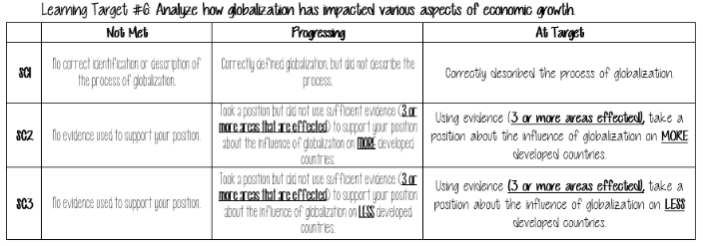
globalization assessment
Take a position about globalization. Is it good or bad? Why?
In your argument for or against globalization, you must include information from all of the areas on the rubric.

