International trade

Directions: After you have read the article on international trade, make sure you watch the video below before moving on.
https://www.youtube.com/watch?v=PA45kPy1tW8

- What are the benefits of free trade?

- What are the negative aspects of free trade?

- Overall, do the positives outweigh the negatives or the negatives outweigh the positives with free trade? Explain your thinking.

How and why do countries regulate trade
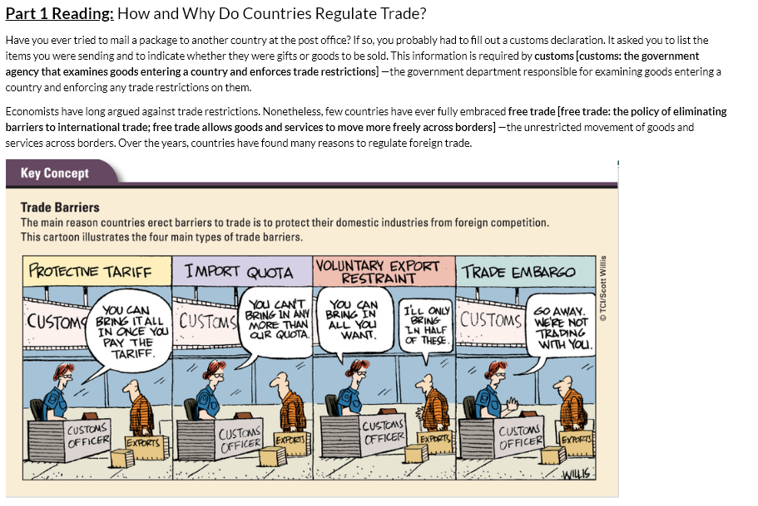
Take notes on the reading

NOTES:

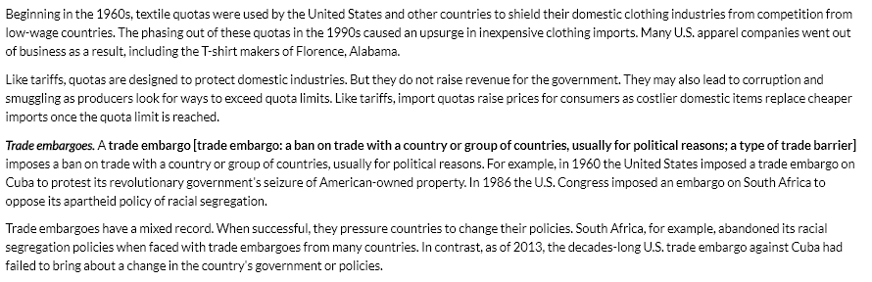
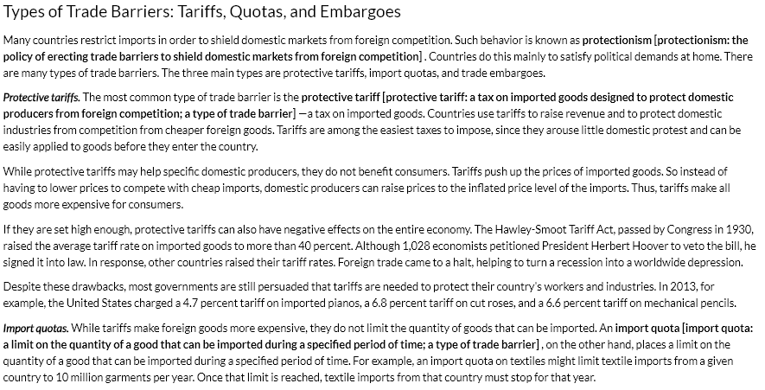
NOTES:

Why do countries use trade barriers?
Watch the video below and take any notes you think are necessary
Video: https://www.youtube.com/watch?v=FMTO8Uy5NCI

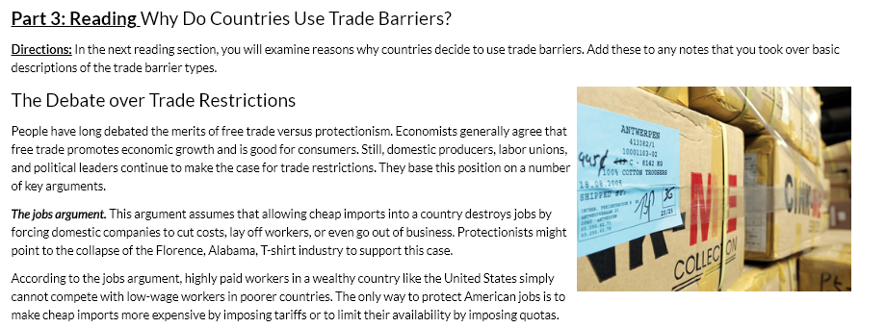
Notes:

NOTES:

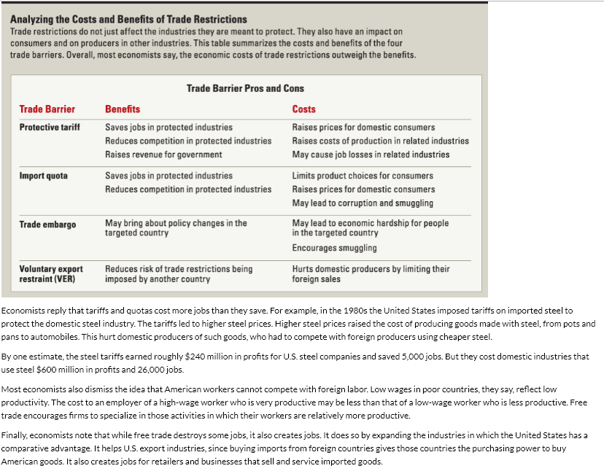
NOTES:

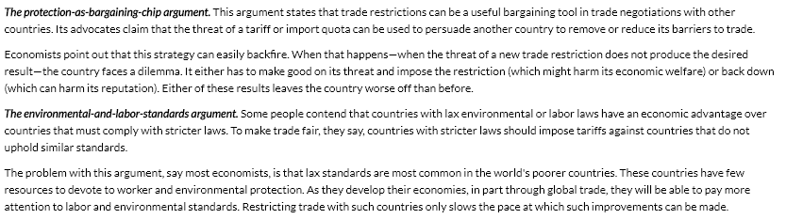
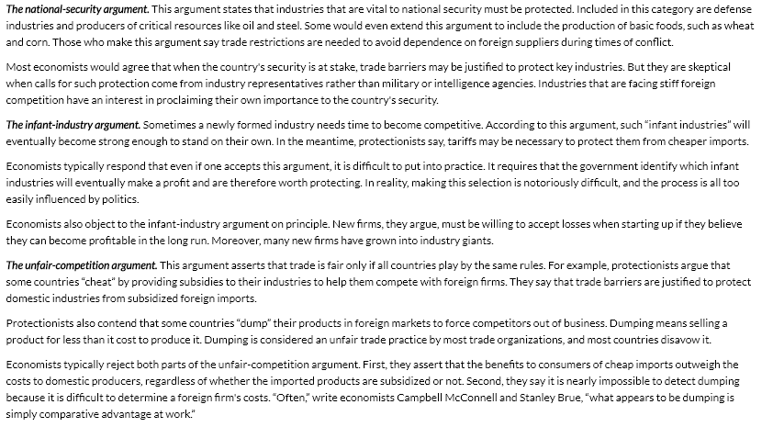
NOTES:

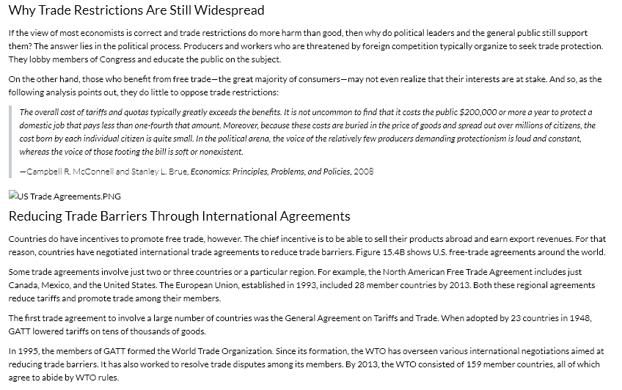
NOTES:

Trade barriers “quiz”

- Matching
Tariff | Quota | Embargo

- A(n) places a limit on the amount of product that can imported. It causes there to be a shortage of the product imported to encourage customers to buy domestic products.

- A(n) forbids trade with another country. When countries use this, it tends to send a strong political message.

- A(n) is like a tax. It causes the price of the item to be higher.

- Describe how tariffs affect consumers and producers in both the country using the tariff and the country that the imports are being restricted from.

- Describe how quotas affect consumers and producers in both the country using the tariff and the country that the imports are being restricted from.

- Describe how embargoes affect consumers and producers in both the country using the tariff and the country that the imports are being restricted from.

Trade regulations
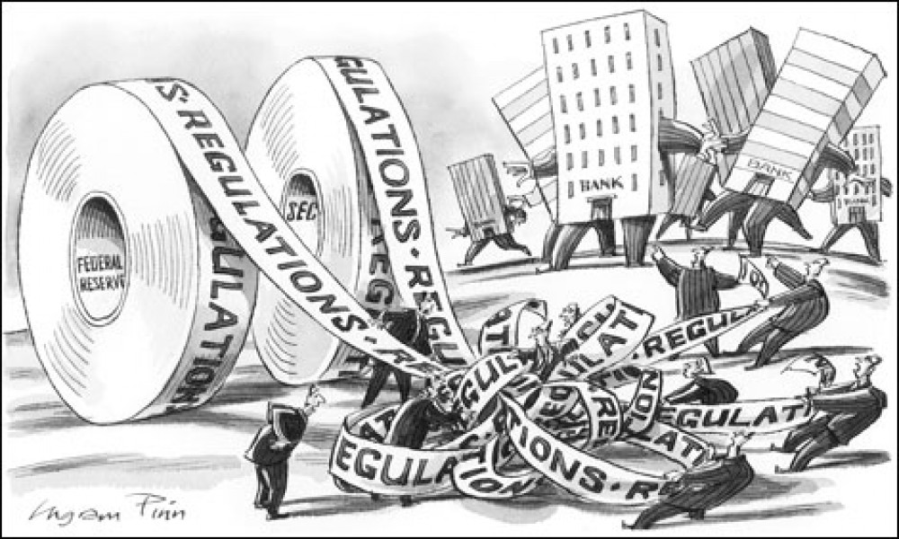

Directions: You will choose one scenario below to “fix”. You will take a position to promote free or restricted trade. In this discussion you are fixing trade problems with one of the trade restrictions or free trade and then justifying your response.
Choose ONE of the options below:

Scenario #1: Caterpillar Inc moves their engine manufacturing for construction equipment to Mexico from the United States.
- What are the positive and negative effects of this choice to workers, big businesses like Caterpillar, and small local businesses?
- Which trade restriction could you use to fix the negative from the first question?
- Why does that trade restriction work to fix the problem?
- What new problems are created by using that trade restriction?

Scenario #2: Due to free trade the United States imports $480 billion worth of goods from China and China imports $170 billion worth of goods from the United States. Because of this the United States and China have a $310 billion trade deficit.
- What are the positive and negative effects of this choice to workers, big businesses, and small local businesses?
- Which trade restriction could you use to fix the negative from the first question?
- Why does that trade restriction work to fix the problem?
- What new problems are created by using that trade restriction?
Scenario #3: Kim Jong-un, the leader of North Korea, is seeking to create a free trade agreement with the United States to provide needed food and other resources to his country.
- What are the positive and negative effects of this choice to workers, big businesses, and small local businesses and the global message this sends about the United States?
- Which trade restriction could you use to fix the negative from the first question?
- Why does that trade restriction work to fix the problem?
- What new problems are created by using that trade restriction?

