Unit 4
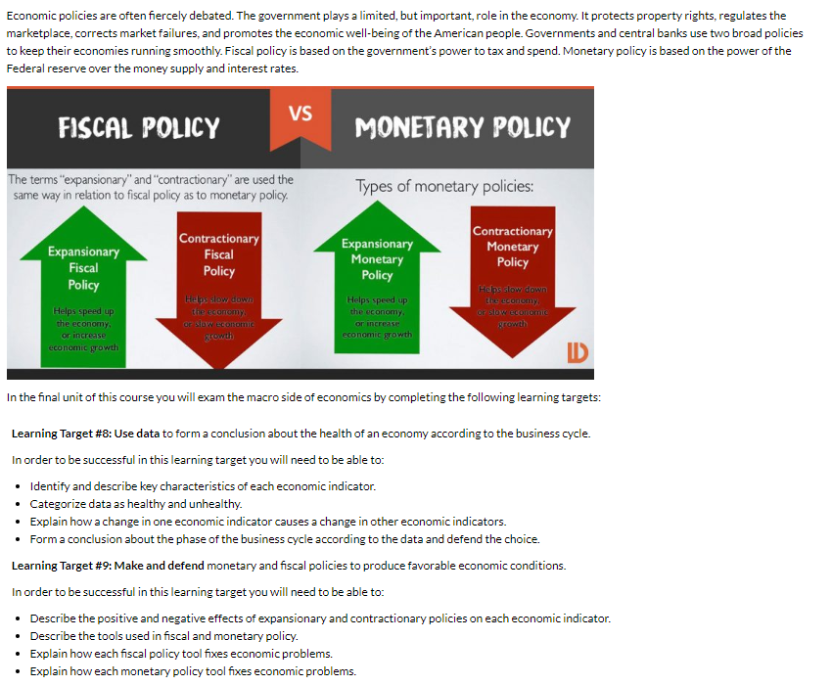
Is our economy healthy?

Economic indicator 1: GDP

Directions: Use the reading and video below to take notes (next page) on the first economic indicator. Below are guiding questions that will help you with your next assignment.
- What types of activities are included in the calculation of GDP?
- How would you describe what GDP measures about the overall economy?

GDP (Gross Domestic Product)
The main measure of the size of a nation’s economy is its gross domestic product. GDP is an economic indicator that measures a country’s total economic output. In formal terms, gross domestic product is the market value of all final goods and services produced within a country during a given period of time. A steadily growing GDP is generally considered a sign of economic health.

This is the actual definition broken apart to help you understand:
- The market value . . . Our economy produces a vast variety of goods and services, everything from guitar lessons to computers. How can anyone add them all together to come up with a single measure of an economy's output? The Bureau of Economic Analysis does so by attaching a market value to each product. Market value is the price buyers are willing to pay for a good or service in a competitive marketplace.

- Of all final goods and services . . . GDP is based on the market price of every “final” good or service that can be legally sold in a country. A final good is any new good that is ready for use by a consumer. A box of cereal is a final good, as is a new car. Goods that are used in the production of final goods, such as the grains used to produce cereal or the steel and rubber used to manufacture cars, are known as intermediate goods. Their market value is not counted in GDP because it is already included in the market value of the final good.

- Produced within a country . . . To be included in GDP, goods and services must be produced within the country's borders. The firms that produce the goods and services do not necessarily have to be American owned. Cars manufactured in the United States by the Japanese automaker Toyota, for example, are included in this country's GDP.

- During a given period of time. The Bureau of Economic Analysis calculates GDP every quarter, or three-month period. Economists use the calendar year GDP to compare production from year to year or from country to country. This annual GDP includes all final goods and services produced between January 1 and December 31. Goods do not have to have been sold during that period to be included in GDP. For example, a kayak manufactured in 2013 but sold in 2014 would be included in the 2013 GDP.

Video: https://www.youtube.com/watch?v=1Il5IQHcYP8
GDP Notes
- What does GDP stand for?________________________ ____________________________________ ________________________________
- Define GDP: __________________________________________________________________________________________________________________________________________________________________________________________________________________

- While watching the video, answer the following questions:

  - What is TOTAL MARKET VALUE?____________________________________________________________________________
__________________________________________________________________________________________________________________________________________________________________________________________________
  - What are FINAL GOODS?______________________________________________________________________________________
____________________________________________________________________________________________________________________________________________________________________________________________________________________________________
  - What are Intermediate goods? _______________________________________________________________________________
____________________________________________________________________________________________________________________________________________________________________________________________________________________________________
  - What does PRODUCED WITHIN AN ECONOMY mean when discussing GDP?____________________________
____________________________________________________________________________________________________________________________________________________________________________________________________________________________________
  - What should we look at if we want to know if GDP is growing?
Circle one: Dollar amount of GDP or Percent of GDP?
  - What is GDP Per Capita? _____________________________________________________________________________
Why is GDP Per Capita useful? ______________________________________________________________________
Reading Part 1 Questions
- Give an example of an economic activity included in GDP, and explain why it is included.

- Give an example of an economic activity NOT included in the calculation of GDP, and explain why it is NOT included.

GDP “Quiz”

- You spend $7.00 to attend a movie. Is this included in the current calculation of GDP?

- You buy a new Toyota made in Japan. Is this included in the current calculation of GDP?

- A family buys a house built three years ago. Is this included in the current calculation of GDP?

Reading Part 2: How Economists Calculate GDP.
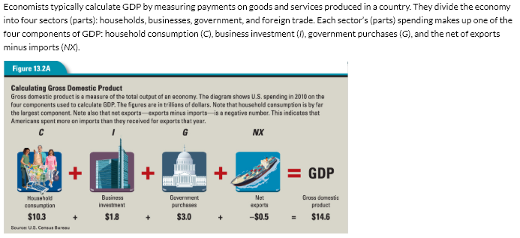

Economists calculate GDP using this formula:
C + I + G + NX = GDP
Household consumption, C. This component of GDP consists of goods and services bought by people in households for personal use. Household consumption ranges from food and fuel to movie tickets and medical care.
Business investment, I. This component consists largely of business investment in capital goods, such as buildings and machinery. It also includes goods produced but not yet sold.
Government purchases, G. Federal, state, and local government purchases of goods and services are also included in GDP. Economists do not count government transfer payments, such as welfare or Social Security benefits, as part of GDP. These payments do not create new production, nor do they involve the purchase of goods or services by the government.
Net exports, NX. In calculating the impact of trade on GDP, economists focus on net exports the value of all exports minus all imports. This makes sense because when a country exports goods and services, those exports bring money back home. The sale of these goods increases the exporting country’s GDP. Just the opposite happens, however, when a country imports goods and services. The money used to pay for these imports leaves the economy, thus decreasing the importing country’s GDP.
Net exports can be either positive or negative. When exports exceed imports, net exports are positive and increase GDP. When imports exceed exports, net exports are negative and decrease GDP.

Reading Part 2 Questions
- C + I + G + Nx = GDP. This is the formula used to calculate GDP. Explain (not define) each component of the formula.
C =

I =

G=

Nx=

GDP Components Discussion

Directions: All of the following are included in GDP but, which category?

Household Consumption Business Investment Government Spending Net Exports

- A radio produced and sold in the US by a Japanese company.

- College Tuition

- The production of a new car factory in Tennessee

- Investment in a new Mars colony research project by NASA.

- China’s economy is growing, and they demand more corn from Iowa farmers.

6. You go to dinner and a movie with your partner.

What is a business cycle?
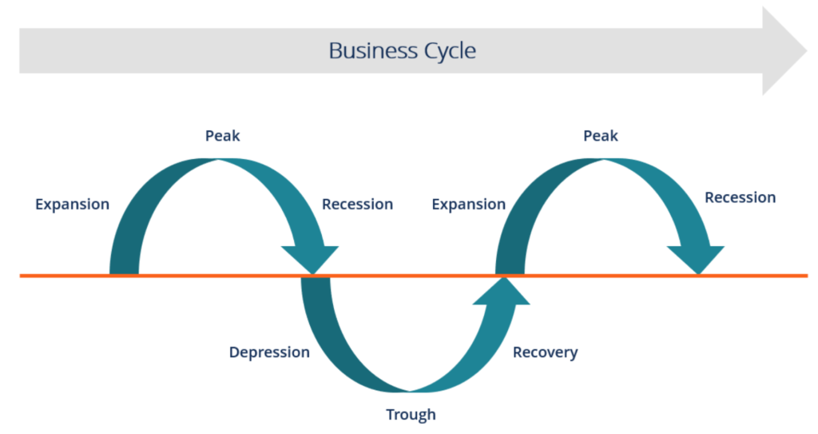
The business cycle is alternating periods of rising and falling GDP. It shows the ups and downs in total output (GDP) observed over relatively short time periods—a few months to a few years. Between 1945 and 2010, the United States experienced 12 repetitions of the business cycle.

Phases of the Business Cycle
Although no two business cycles are exactly alike, they all experience the same two phases: expansion and contraction. During expansion or an expansionary phase, GDP rises. This usually brings along higher income levels. When people have more money, their demand for goods and services increases. Firms bring in more money through sales and usually hire more employees, making it easier for people to find jobs.

During contraction or a contractionary phase, GDP falls. Economic contractions make life more difficult. People have less money to spend, firms hire fewer workers or may even lay off workers, and more firms go out of business. When a contraction is severe enough to last several months or longer and have widespread negative effects on production, income, employment, and sales across an economy, it becomes a recession.

Peaks and Troughs
The business cycle has a wave-like appearance when graphed. When an expansion is ending and the economy will proceed into a contraction, the business cycle is at a peak, shown by the highest point in each cycle on the graph. The lowest point in a cycle, where contraction ends and expansion begins, is called a trough. In other words, expansion begins at the trough and ends at the peak. Contraction begins at the peak and ends at the trough.
Usually expansionary phases last longer than contractionary phases. Since World War II, the average contraction lasted about 11 months, while the average expansion continued for 5 years. The most recent recession (2007-2009) lasted a full 18 months and was the worst economic recession in the United States since the Great Depression.
VIDEO: https://www.youtube.com/watch?v=SYFYla1H7KE

NOTES:

GDP and the business cycle

Directions: Choose a country other than the United States. Go to www.cia.gov/library/the-world-factbook and find your country of choice. (Hint: Sometimes it is easier to choose a country and type it into google along with CIA World Factbook)

Go to the Economy section and find the following:

What is your country’s GDP-Real Growth Rate? (the dates may be different)

2017:

2016:

2015:

Which part of the business cycle is your country in according to the data you have collected? How do you know if your country is in a contraction or expansion? Use the data to support your response.

Economic indicators and healthy data

Reading: When evaluating economic data, it is important to know what healthy ranges of GDP, Unemployment, and Inflation are.

As far as GDP is concerned, if GDP is higher than the inflation rate and positive, it is generally considered to be healthy. Ideally economies would grow at a rate of 2-3% each year. When GDP grows too quickly, meaning there is a lot of economic activity it results in inflation. Generally speaking, GDP growth above 5% is considered too high. If GDP is in a contraction phase for 2 consecutive quarters (6 months) it is considered a recession. 8 consecutive quarters (2 years) of a contraction is considered a depression.

When considering unemployment data, a healthy unemployment rate is between 4% and 6% of people being unemployed. When unemployment is below 4% it will usually cause inflation due to the increase in money being spent because most people have jobs. When unemployment gets above 6% it will cause GDP to decrease due to many people not having a job and money to spend which drives down demand for products, eventually leading to producers decrease their production.

Inflation should never exceed GDP growth rate in 1 year. If prices increase too quickly it may contribute to economic decline. An ideal rate of inflation is 2%. We want prices to rise steadily overtime so any change between 0 and 3% is considered healthy.

Summarize:
- How would you know if GDP is healthy?

- How would you know if unemployment is healthy?

- How would you know if inflation is healthy?

Economic indicator #2: Unemployment

Directions: When completing the reading below be sure to take notes about how to best answer the following:
- Explain the difference between employed, unemployed, and not in the labor force.
- Describe each of the FOUR types of Unemployment. Give an example of each.
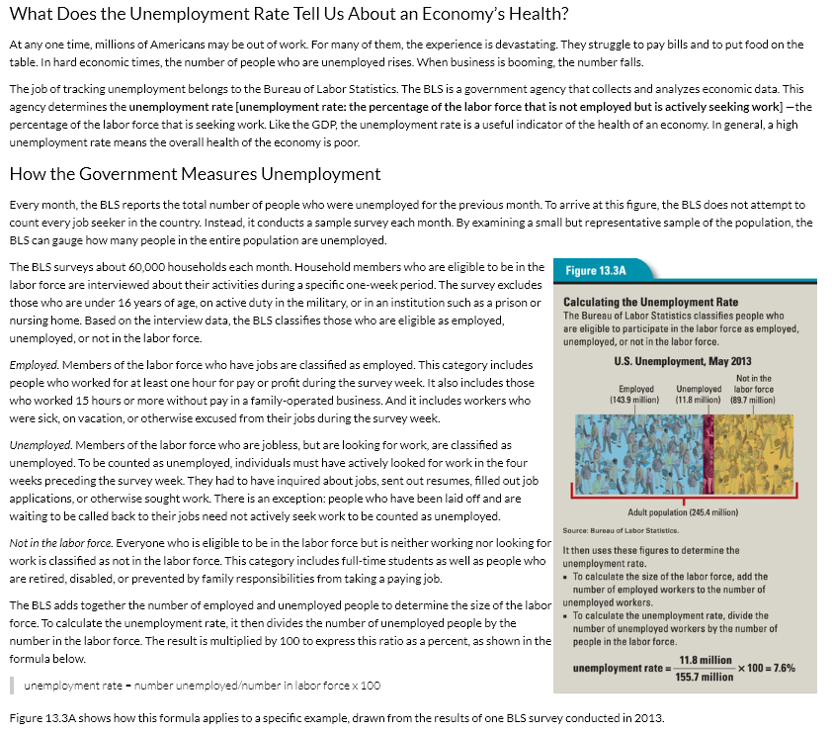
- Which type of unemployment do you think is most associated with an unhealthy economy? Why? Does an economy with full employment have any of these types of unemployment? Why or why not?
NOTES:
NOTES:

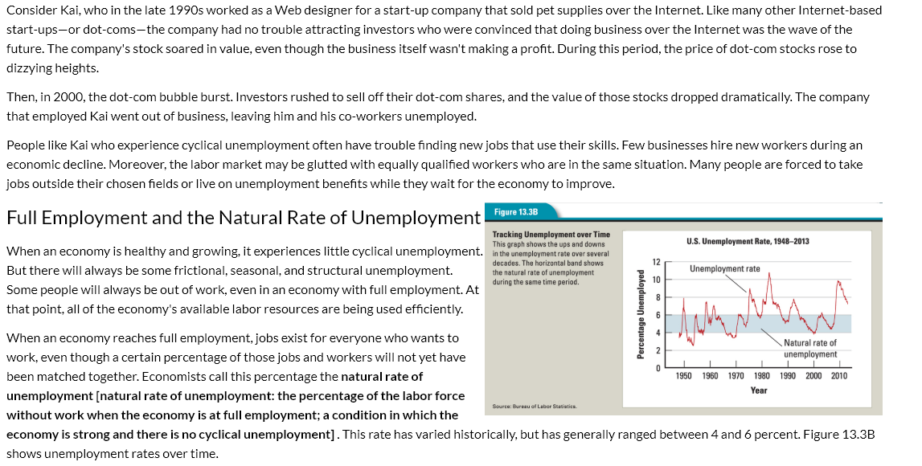
NOTES:

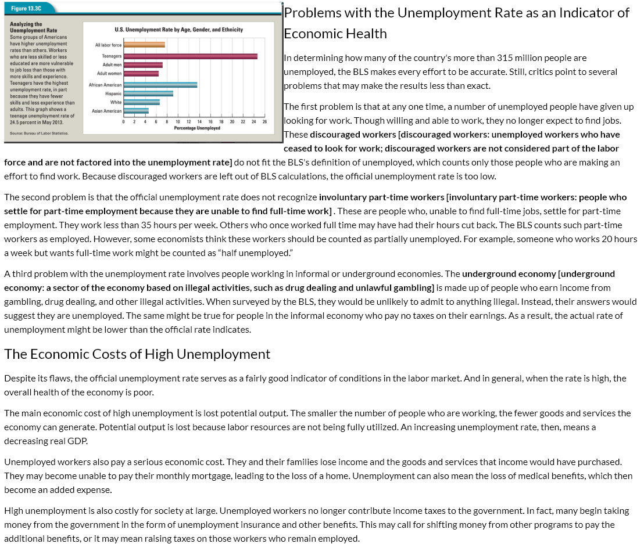
NOTES:

Unemployment discussion

- Explain the difference between employed, unemployed, and not in the labor force.

- Describe each of the FOUR types of unemployment. Give an example of each.

- Which type of unemployment do you think is most associated with an unhealthy economy? Why?

- Does an economy with full employment have any of these types of unemployment? Why or why not?

Unemployment “Quiz”

Directions: For each situation, choose the correct type of unemployment.

Cyclical Structural Seasonal Frictional Not in the Labor Force

- A computer programmer is laid off because of a recession

- A literary editor leaves her job in New York to look for a new job in San Francisco

- An unemployed college graduate is looking for his first job

- Advances in technology make the assembly-line worker’s job obsolete

- Slumping sales lead to the cashier being laid off

- An individual refuses to work for minimum wage

- A high school gradate lacks the skills necessary for a particular job

- Workers are laid off when the local manufacturing plant closes because the product made there isn’t selling during a recession.

Economic indicator #3: Inflation

Directions: As you complete the reading on this page and the next, think about the following questions
- Describe why the three types of inflation happen:
- Creeping
- Hyperinflation
- Deflation
2. Why does inflation happen?
- Demand pull...
- Cost push...
- Summarize the wage price spiral. Explain (using information from the wage price spiral) Why did inflation occur when the Acme Truckers received a raise.
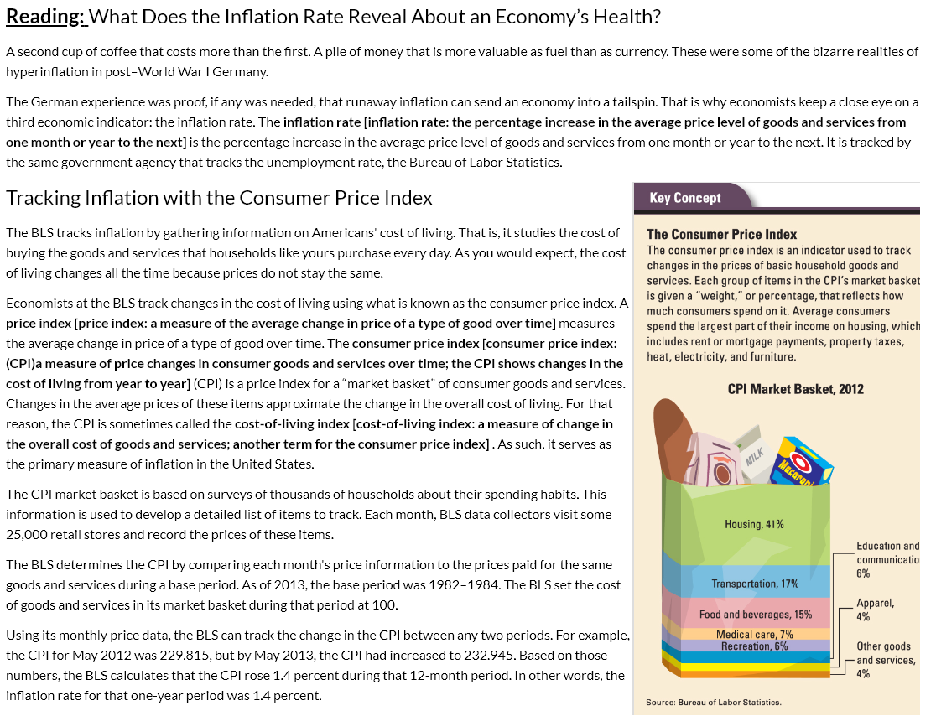
NOTES:

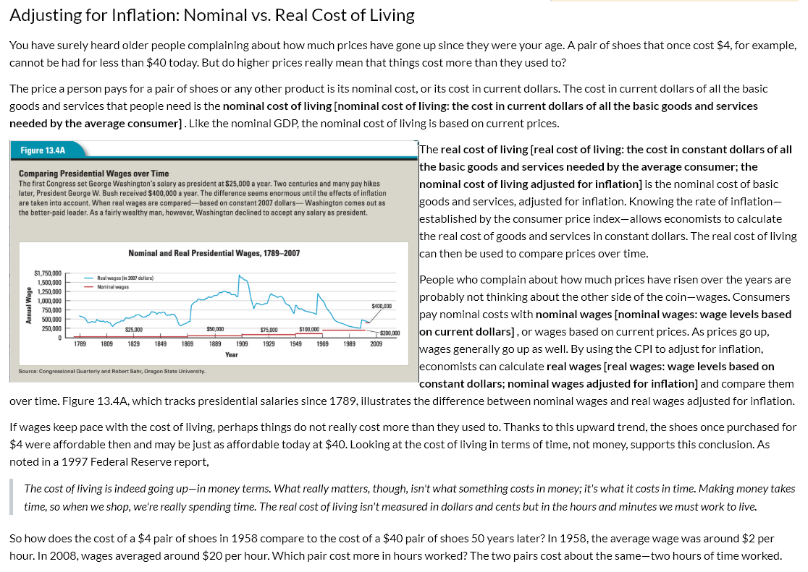
NOTES:

Reading: Creeping Inflation, Hyperinflation, and Deflation

In an ideal world, prices would be stable, neither rising nor falling over time. In our real world, prices are always changing. The result can be creeping inflation, hyperinflation, or deflation.
Creeping inflation. In the United States we have come to expect a certain amount of gradual inflation, or creeping inflation [creeping inflation: a gradual, steady rise in the price of goods and services over time], every year. Since 1913, the average annual rate of inflation has been about 3.2 percent. For much of that period, the rate has varied widely. But during your lifetime it has stayed fairly close to that average. For Americans, this is normal inflation—the level we are used to.

Hyperinflation. Occasionally inflation goes into overdrive. The result is hyperinflation. Runaway inflation creates extreme uncertainty in an economy. Nobody can predict how high prices will go, and people lose confidence in their currency as a store of value.
A number of countries have experienced hyperinflation since Germany in the 1920s. The African country of Zimbabwe is one example. Zimbabwe began its plunge into crisis in 2000, when the government seized thousands of white-owned farms. Foreign investors fled. Unemployment shot up. Food shortages became severe. The government responded to the crisis by printing money, adding trillions of Zimbabwean dollars to the money supply each year.
As the Zimbabwean dollar lost value, inflation skyrocketed. Vending machines that took coins quickly became unusable. One soda would have required the deposit of billions of coins. By early 2008, the official annual inflation rate had topped 100,000 percent. With the price of goods doubling every few days, farms and factories shut down and standards of living collapsed.

Deflation. The inflation rate is usually a positive number, meaning that the overall price level is rising. But the inflation rate can be negative, a condition that economists call deflation [deflation: a fall in the price of goods and services; the opposite of inflation]. Deflation occurs when prices go down over time.

Deflation is good news for consumers and savers. The value of every dollar they set aside now to spend later will increase over time as prices fall. Deflation is also good for lenders. The dollars they receive from borrowers tomorrow will be worth more than the dollars they lent them yesterday. This increase in the value of dollars can be painful for borrowers, however.
Deflation may also be bad news for businesses. When prices are dropping, people tend to put off spending, hoping for still lower prices later on. As consumer spending slows, businesses cut wages, lay off workers, and may even go bankrupt. The result can be a deflationary spiral, such as occurred in the early days of the Great Depression. In a deflationary spiral [deflationary spiral: a downward trend in prices, wages, and business activity; a deflationary pattern in which falling prices cause a business slow-down, which in turn leads to lower wages, a further fall in prices, and even less business activity] , falling prices lead to business slowdowns, which lead to lower wages, which lead to still lower prices, and so on.

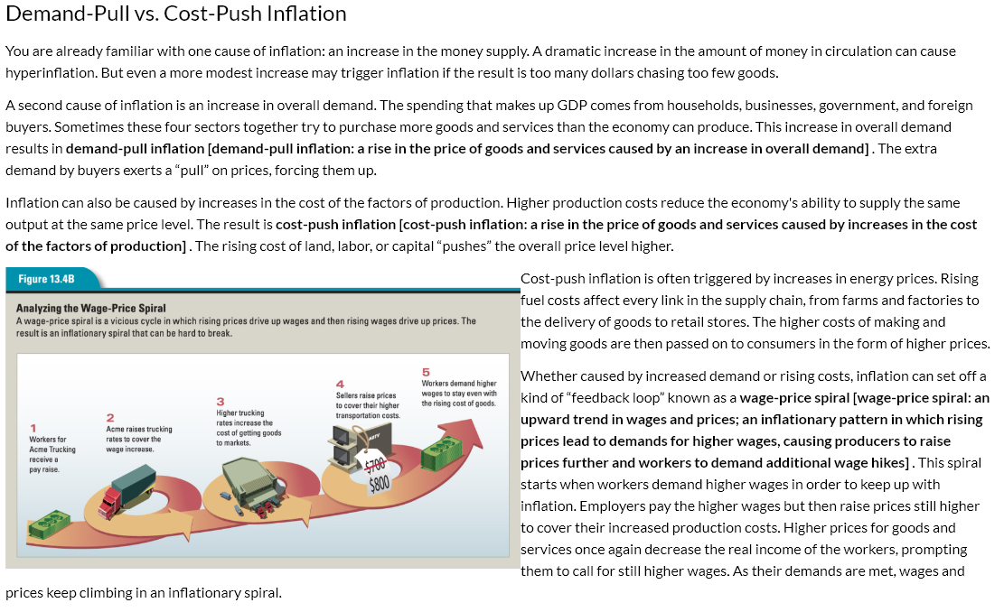
NOTES:

Inflation discussion

- Describe why the three types of inflation happen:
- Creeping

- Hyperinflation

- Deflation

2. Why does inflation happen?
- Demand pull...

- Cost push...

- Summarize the wage price spiral. Explain (using information from the wage price spiral) Why did inflation occur when the Acme Truckers received a raise.

Unemployment and inflation country research

Directions: For the SAME country you researched previously, complete the following:

Go to CIA World Factbook

Find your country and go to the economy section

Unemployment Rate
2017:

2016:

2015:

Inflation Rate (Consumer Prices)
2017:

2016:

2015:

Write a paragraph explaining whether the country’s economy you chose is healthy or unhealthy according to the statistics you found in your research. USE STATISTICS TO MAKE YOUR CASE.

