Monetary and fiscal policies
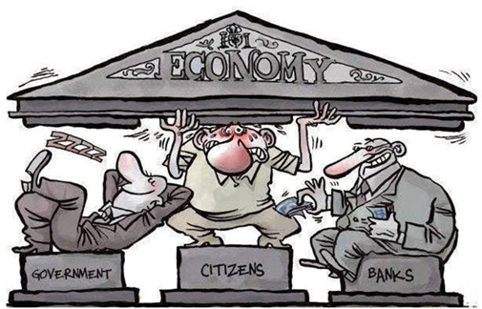
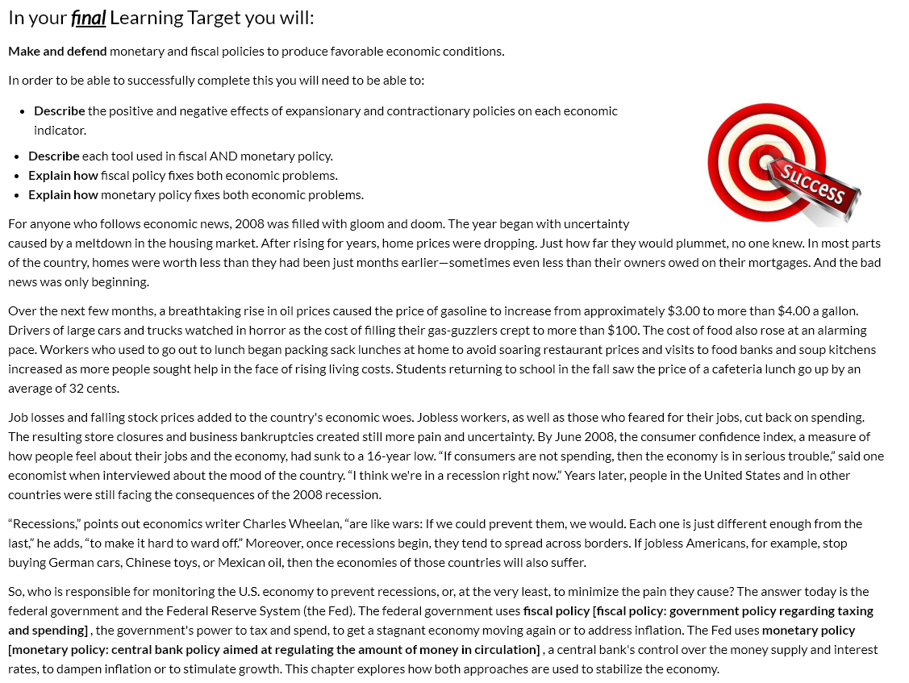
Expansionary and contractionary policy

Directions: Using the chart/picture below and your knowledge from LT 8 about economic indicators to respond to these questions:
- Why would a government use an expansionary policy? How does it work?

- What is the negative side-effect of the government using an expansionary policy? How does that happen?

- Why would a government use a contractionary policy? How does it work?

- What is the negative side-effect of the government using an contractionary policy? How does that happen?

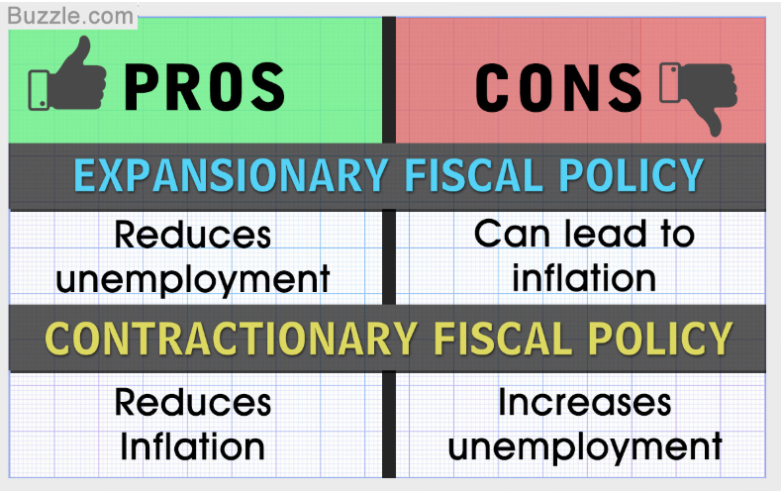

What are fiscal policy and monetary policy?
Directions: Use the reading below to help you respond to the following questions. On the next page you will complete a short check in creating a summary of each fiscal and monetary policy tool.
- Who creates fiscal policy?
- Who creates monetary policy?
- Describe each fiscal policy tool?
- Describe each monetary policy tool?
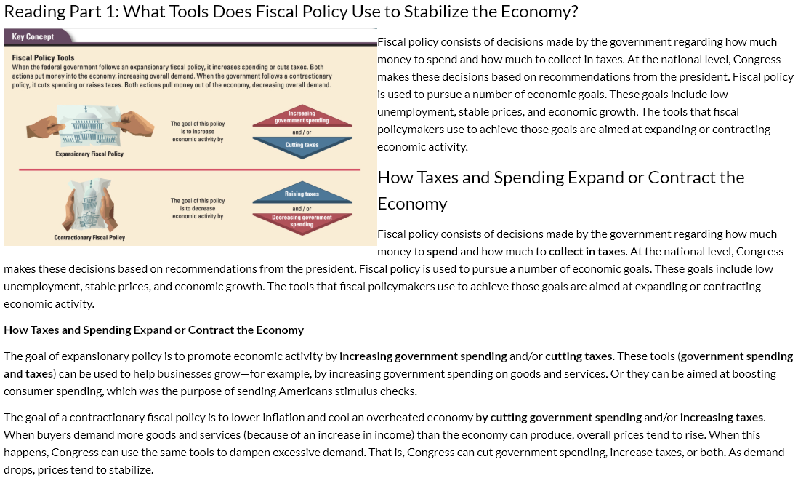
NOTES:

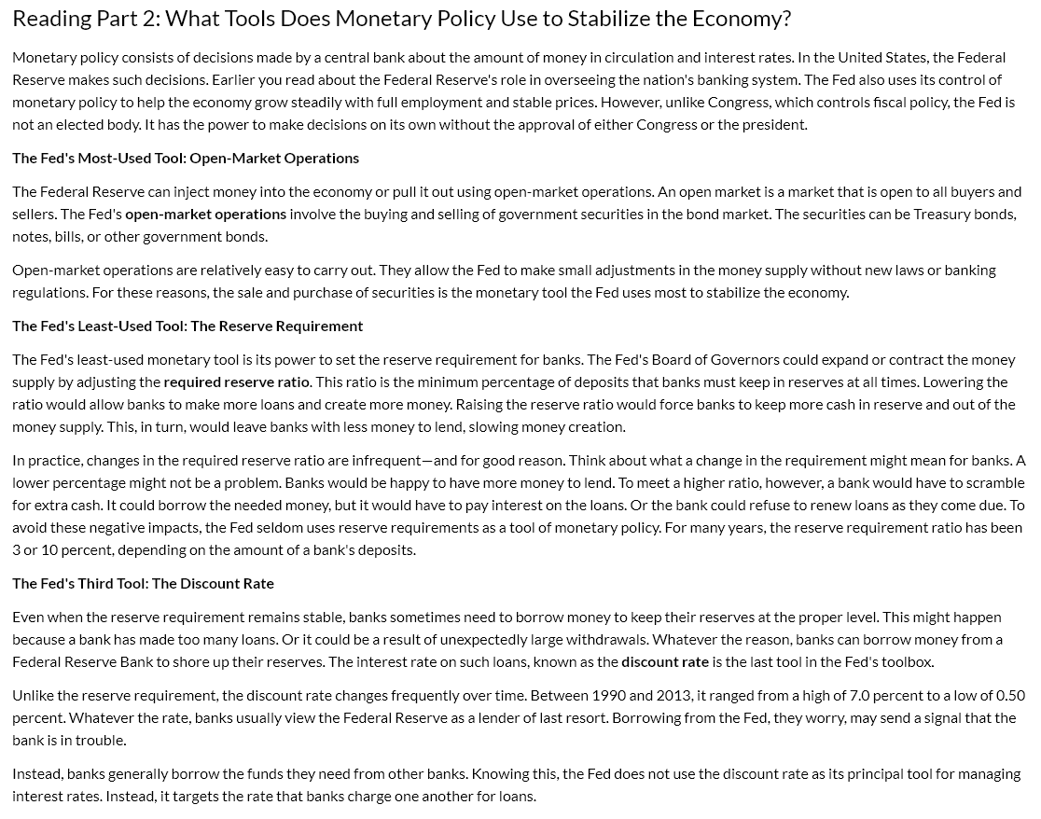
NOTES:

Fiscal and Monetary Policy Tools “Quiz”

- creates fiscal policy.

- creates monetary policy.

- Describe each tool (taxes and spending) used in fiscal policy

- Describe each tool (government securities/bonds, discount rates, and reserve requirement) used in monetary policy.

How does Fiscal Policy work?

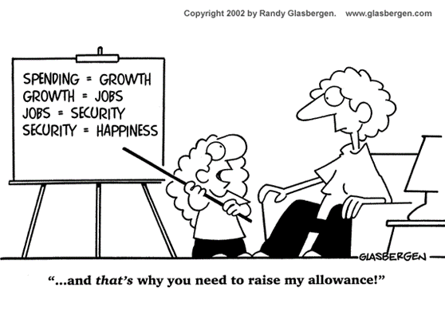

Directions: Using the reading and video below gather information about how fiscal policy works to fix the problems of high unemployment/low growth or high inflation through the use of expansionary and contractionary policies.
Questions to take notes over:
- What does the federal government do with taxing and spending to fix the problem of Inflation?
- Why does this work?
- What does the federal government do with taxing and spending to fix the problem of High Unemployment/Low Growth?
- Why does this work?

Video: Overview of Fiscal Policy
https://www.youtube.com/watch?v=4FNdUTN4cHY

NOTES:

Reading: Fiscal Policy
Using Tax Cuts to Stimulate Growth
Keynesian economics AKA demand-side economics is the theory which argues that the best way to ensure economic growth is to stimulate demand by putting more money in the hands of consumers, by cutting taxes on lower-income earners.
This theory, which is associated with Keynesian economics, assumes that consumers will spend this additional money on goods and services, thus stimulating the economy. Demand-siders believe that the best way to deal with a sluggish economy is to stimulate overall demand by cutting individual income taxes. As consumers spend their tax savings on goods and services, business will pick up and the economy will begin to grow.

Supply-side economics is the theory which argues that the best way to ensure economic growth is to stimulate overall supply by cutting taxes on businesses and high-income taxpayers; this theory assumes that producers and investors will use their tax savings to expand production, thereby stimulating the economy.

Supply-siders hold that the best way to deal with an economic slowdown is to stimulate overall supply. This can be done by cutting taxes on businesses and high-income taxpayers. As businesses and investors use their tax savings to expand production, the supply of goods and services will increase, spurring economic growth.

NOTES:
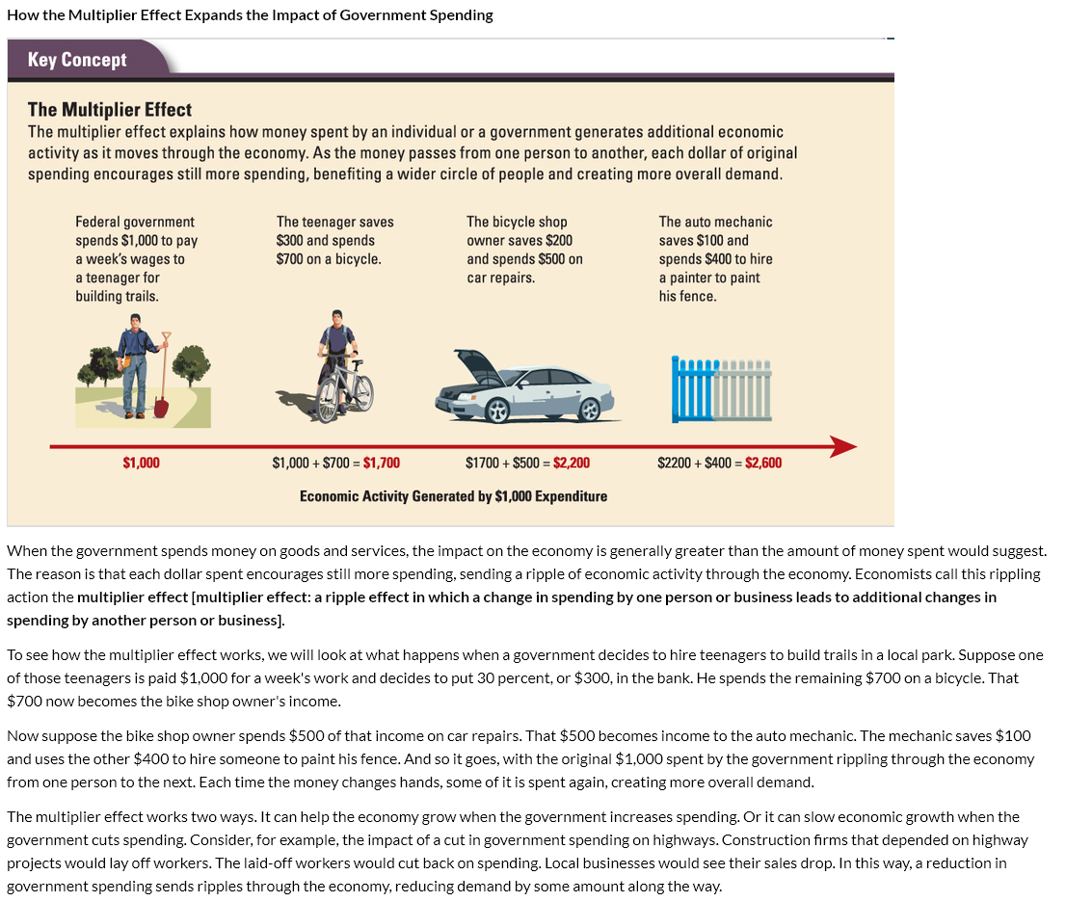
NOTES:

Applying fiscal policy

Directions: Choose TWO of the scenarios to analyze using the prompts below.
- What is the economic problem?
- Should you use expansionary or contractionary fiscal policy to fix the problem?
- How will that policy work to fix the problem you identified? Explain how each FISCAL POLICY tool is used to fix the problem.

Scenario #1:  GDP Real Growth Rate: 18.2%  Unemployment: 4.3%  Inflation: 10.8% | Scenario #2:  GDP Real Growth Rate: -2.5  Unemployment: 14%  Inflation: .7% | Scenario #3:  GDP Real Growth Rate: -1%  Unemployment: 9%  Inflation: -1.5%

How does monetary policy work?

Directions: Using the reading and video below gather information about how monetary policy works to fix the problems of high unemployment/low growth or high inflation through the use of expansionary and contractionary policies.
Questions to take notes over:
- What does the federal reserve do with the reserve rate, discount rate, and bonds to fix the problem of Inflation?
- Why does this work?
- What does the federal reserve do with the reserve rate, discount rate, and bonds to fix the problem of High Unemployment/Low Growth.
- Why does this work?
Video: Money and Monetary Policy https://www.youtube.com/watch?v=RaeIBeJT5hY

Directions: Choose TWO of the scenarios to analyze using the prompts below.
- What is the economic problem?
- Should you use expansionary or contractionary MONETARY policy to fix the problem?
- How will that policy work to fix the problem you identified? Explain how each tool is used to fix the problem.

Scenario #1:  GDP Real Growth Rate: 18.2%  Unemployment: 4.3%  Inflation: 10.8% | Scenario #2:  GDP Real Growth Rate: -2.5  Unemployment: 14%  Inflation: .7% | Scenario #3:  GDP Real Growth Rate: -1%  Unemployment: 9%  Inflation: -1.5%

