Unit 3: What is Life?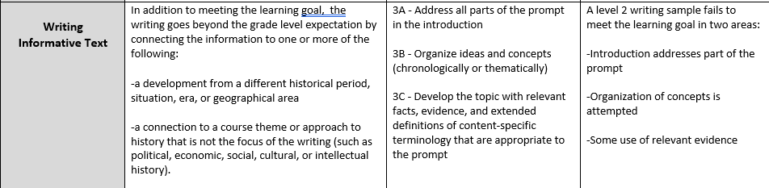

Read the article on Darwin. Explain the conflict between evolution and creation

