Unit 5: Agriculture & Civilization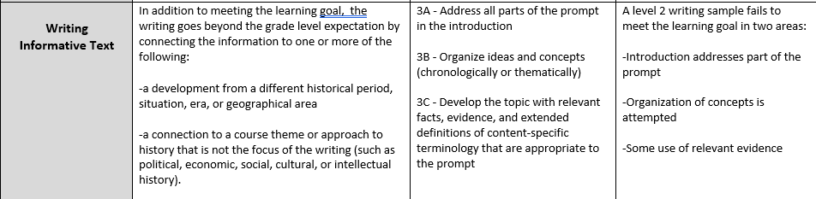

To what extent was farming an improvement over foraging?

