Unit one
Origins & methods
What are social sciences?

What is sociology?

What is social interaction?

What are social phenomena?

Sociology over time
Several factors led to the development of sociology as a distinct field of study. The rapid social and political changes during the European Industrial revolution were the primary cause of the expansion of sociology
Explain how the European Industrial Revolution led to the development of sociology as a social science

Match the sociologist with their contribution
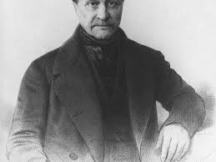
Conducted early sociological studies in Britain and the United States; advocate of the idea that scholars should try to improve society, not just study it; best known for translating Comte’s works into English
AGUSTE COMTE
1798 - 1857

\
Emphasized the primary role that conflict plays in social change and advocated revolution to speed up the process of change; his ideas led to the development of the conflict perspective in sociology
Harriet Martineau
1802 - 1876

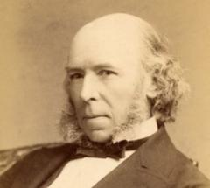
Among the first scholars to apply the methods of the physical sciences to the study of society; coined the word sociology and is considered the founder of the subject.
Herbert Spencer
1820 - 1903

Applied the principles of biology to society; popularized the evolutionary theory of social change and coined the phrase “survival of the fittest.”
Karl Marx
1818 - 1883

Major theoretical perspectives
Sociologists develop theories, or explanations of the relationships among phenomena, in their effort to explain the social world. Theories provide guidance for sociologists in their work and help them to interpret their findings.
There are three theoretical perspectives in modern sociology. Define them

Explain and describe the focus
Functionalist

Conflict

Interactionist

Compare and contrast the three theoretical perspectives

Similarities Differences

Provide an example of how each prospective can be used with a current event

Conducting sociological research
Match the steps of the research process (scientific method) with the correct definition
Pg. 21 in the textbook
Define the Problem

Review the Literature

Form a Hypothesis

Choose a Research Design

Collect the Data

Analyze the Data

Present Conclusions
The Scientific Method
Identify a problem and explain the steps you would take to solve the problem using the scientific method

