Unit two: culture and values
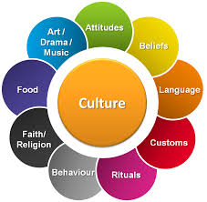
Define and Describe:
Culture

Material Culture

Non-Material Culture

Provide 5 examples of material culture and 5 examples of non-material culture
Material Non-Material
Culture and You
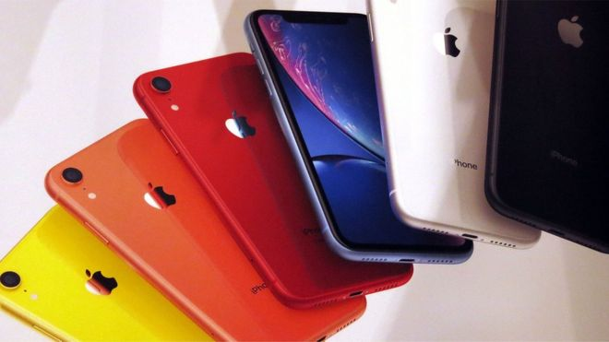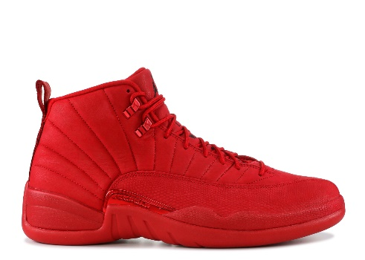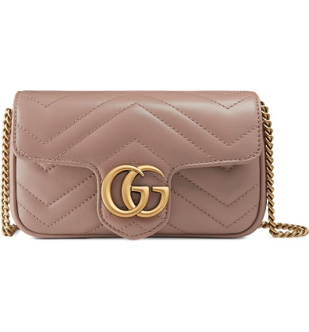

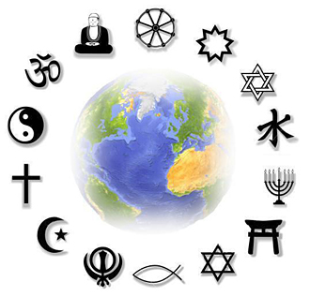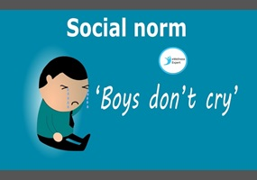

List 5 material or non-material culture items that are important to you/your family and explain their significance:
Example: Everyone in my family has an iPhone because we think Apple products are better and we like having the newest technology.

Investigate the elements of culture
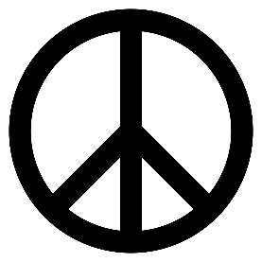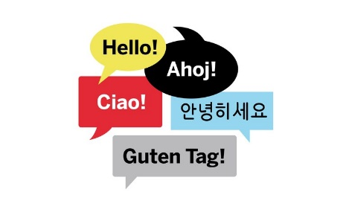

Culture is both learned and shared. Specific examples of the material and non-material elements of culture vary form society to society, but all cultures have certain basic components such as technology, symbols, language, values, and norms.

 | Define | Example | Draw a Picture
Technology

Symbols

Language

Values

Norms

Values

What can be inferred about the values of two societies with different forms of government, such as a republic (democracy) and a monarchy (kings/queens)?

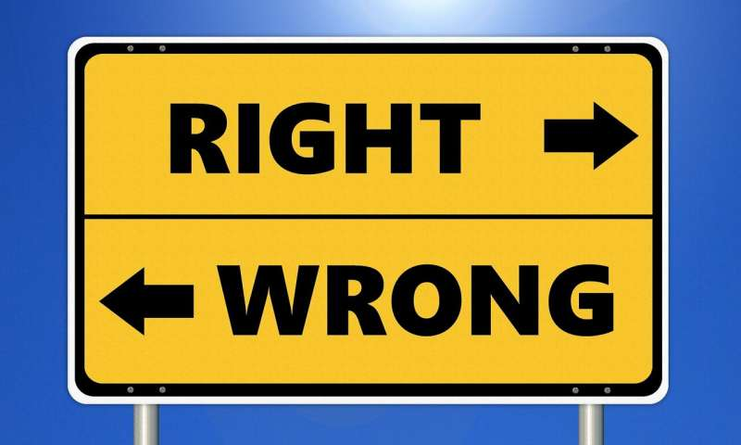
Give and defend your opinion about the way the norm against taking life is applied to soldiers.
Cultural variation
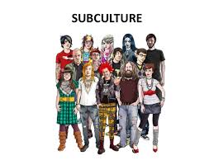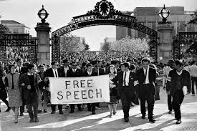

Cultural Universals | Subculture | Counterculture | Ethnocentrism

- The act of judging another culture based on preconceptions that are found in the values and standards of one’s own culture. – especially regarding language, behavior, customs, and religion

- Features common to all cultures.

- A subculture whose values and norms of behavior differ substantially from mainstream society (behaviors are opposite normal values).

- A group of people within a culture that differentiates itself from the parent culture to which it belongs, often maintaining some of its founding principles.

What is the difference between a subculture and a counterculture?

Response to variation
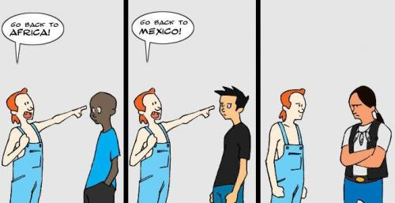
What is cultural relativism?

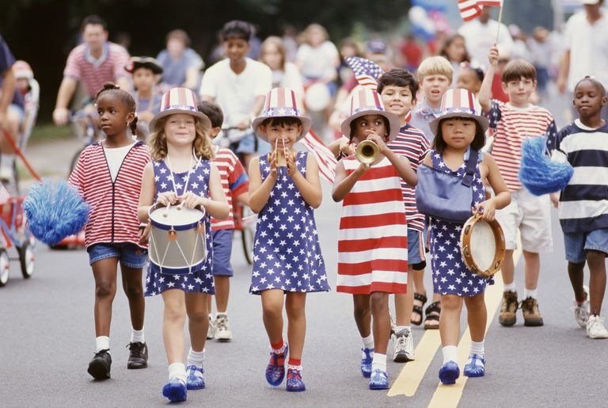
Is ethnocentrism the same as patriotism? Why or why not?

Choose an event, past or present, that resulted form ethnocentrism. Write a short paragraph explaining what ethnocentrism is and describing the event it caused.
American values
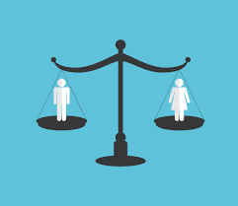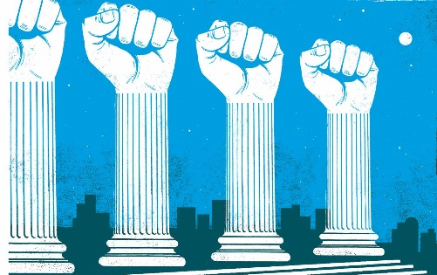

Identify 5 American Values (pg. 45):

Perspectives on culture
Explain how each perspective on culture relates to cultural variation
Functionalist Perspective | Conflict Perspective | Interactionist Perspective

Cultural Change and conformity
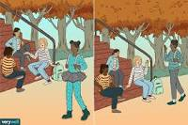

All cultures around the world are constantly changing. Sometimes this change comes very slowly. At other times, change happens suddenly. Change can occur in both material and nonmaterial cultures, and a change in one area of life normally means that other areas will change, too.
Cultural Diffusion | Cultural Lag | Cultural Leveling

- A process in which cultures become more and more alike

- The spreading of culture traits – ideas and beliefs as well as material objects – from one society to another

- The time between changes, when ideas and beliefs are adapting to new material conditions.

Have American values changed over time? Research values from the past 100 years to now. Explain how they are different or the same.

Analyzing material culture
Directions:
Think about all the items you own right now. Select two of those items. One should be of high value to you and the other of little value. You can think whatever terms of value you want to: valuable/worthless, pretty/ugly, good/bad, etc. After selecting your two items, analyze how you chose them by answering the questions below in detailed paragraphs.

- How difficult was it to select only two items?

- What process did you use to eliminate items and settle on the two you chose?

- What were some of the items you considered, but did not choose? Why?

- Which item did you assign a negative value to? Why have you kept it? What value or purpose does it hold for you?

- Why did you assign positive value to the other item? What value or purpose does it hold for you?

