TOPIC: ANALYZING MULTIPLE SOURCES
Name: ________________

Topic | 4 | 3 | 2
Analyzing Multiple Sources (DBQ)  (RH.9) | In addition to meeting the learning goal, the response assesses one or more of the following:  - Reliability of the source(s)  - Usefulness of the source(s)  - Limitations of the source(s) | Uses at least three documents to make a claim in order to answer a question or solve a historical problem.  The response analyzes the documents to use as evidence by including more than one of the following:  - Author’s point of view  - Purpose of the document  - Intended audience  - Historical context | Uses documents as evidence to make a claim in order to answer a question or solve a historical problem.  The response is a summary or description, not an analysis of the documents.

Directions: The question below is based on accompanying documents. The documents have been edited for the purpose of this exercise.

In your response you should do the following:
- Make a claim to answer the question.
- Support the claim with evidence from at least three of the documents.
- Incorporate analysis of at least three of the documents. Focus your analysis on at least one of the following: intended audience, purpose, historical context, or author’s point of view.

Explain the reasons why conservatism rose to prominence in the United States between 1960 and 1989.

Document 1
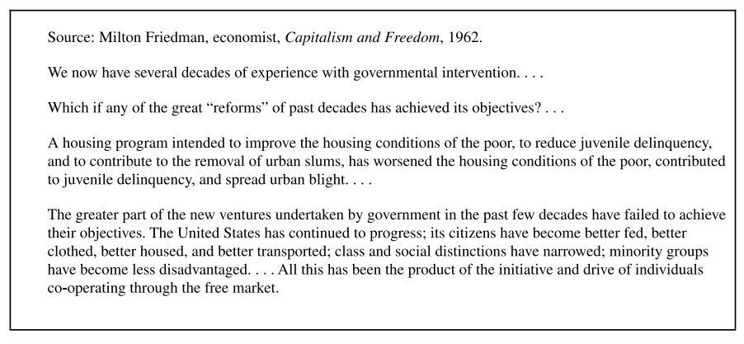

Document 2

Document 3

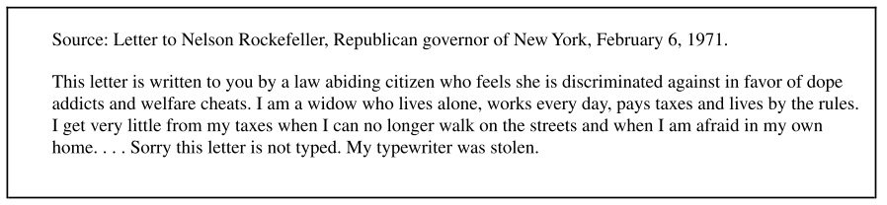

Document 4
Source: Woodstock, Associated Press File Photo, 1969.

Document 5
