UNIT 1: Imperialism Name: ____________________
TOPIC: Source Analysis

2 | 3 | 4
Determines the central idea by citing evidence, but fails to accurately address historical context and/or author’s point of view. | Accurately determines the central idea by citing evidence, addressing the historical context, and explaining the author’s point of view. | In addition to meeting the level 3 expectation, the response includes the use of extended, content-specific vocabulary or makes connections to prior learning and/or current events.

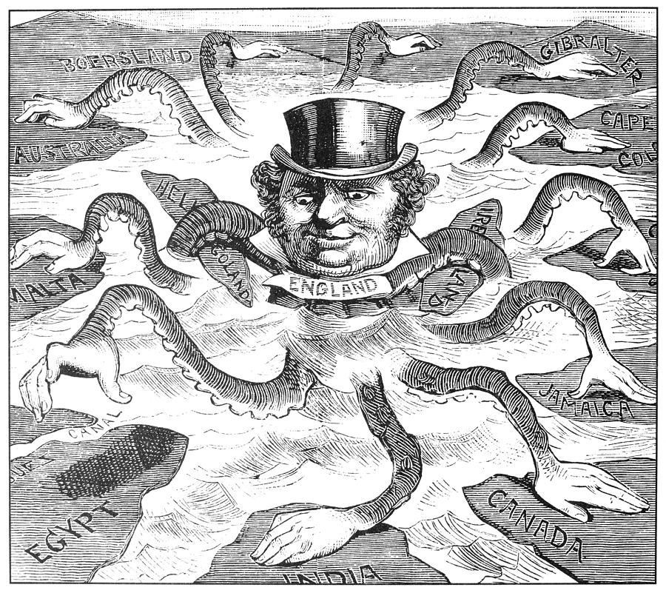

Use the questions below to help you analyze the document.

- What is the central idea of the document? (What’s this all about?)
- What evidence from the document can you use to support the central idea?

- How does this document fit into the historical context? (How does it relate to our unit of study?)
- What’s the author’s opinion on the subject?

- Describe any connections to prior learning or current events.

