UNIT 4: Cold War TOPIC: Analyzing Multiple Sources (DBQ) Name: ____________________

2 | 3 | 4
Attempts to use more than one document on the same topic to take a stand on an issue (thesis). Evidence used from the sources to explain and support the position (claim) may have some misconceptions or inaccuracies. | Uses at least three documents on the same topic to take a stand on an issue (thesis). Accurately uses evidence from three or more sources to explain and support the position (claim). | In addition to meeting the level 3 expectation, the response includes prior knowledge or outside information to enhance the position and recognizes and responds to the opposing viewpoint (counter claim).

What were the motives [ambitions/desires/aims] of the US and USSR during the Cold War?

Use the questions below to help you analyze documents A-E.

- What is the central idea of the document? (What’s this all about?)

- What evidence from the document can you use to support the central idea?

- How does this document fit into the historical context? (How does it fit into our unit of study?)

- What’s the author’s opinion on the subject?

- Will this document support your claim? If so, how? If not, why not?

Document A
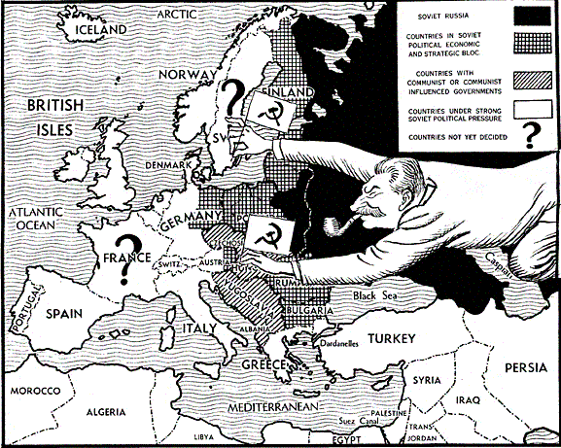
Document B
“I believe it must be the policy of the United States to support free peoples who are resisting attempted subjugation [domination] by armed minorities or by outside pressure. The seeds of totalitarian regimes are nurtured by misery and want. They spread and grow in the evil soil of poverty and strife. They reach their full growth when the hope of a people for a better life has died. Therefore, I propose giving Greece and Turkey $400 million in aid.”
–Excerpt from President Truman’s speech to Congress concerning providing aid to Turkey and Greece as they faced Soviet invasion, March 12, 1947.

Document C
“I need to say that the world situation is very serious. . . . Europe must have a great deal of additional help, or face heavy economic, social, and political damage. This would have a harmful effect on the world at large. There are also possibilities of disturbances [wars] because of the desperation of the people concerned. . . . So the United States should do whatever it can to help restore normal economic health to the world. Without this there can be no political stability or peace. Our policy is directed . . . against hunger, poverty, desperation and chaos [disorder]. Its purpose is to revive a working economy in the world.”
-Excerpt from U S Secretary of State Marshall’s speech explaining his plan for European recovery, June 5, 1947.

Document D
The inspirers of the “cold war” claim they [formed NATO] for defense against the “communist threat.” But this is sheer hypocrisy! . . . Today the “anti-communism” slogan is being used as a smoke screen to cover up the claims of one power for world domination. The United States wants, by means of blocs and pacts, to secure a dominant position in the capitalist world. . . . [They] offer the arms race as their main recipe for the preservation of peace! It is perfectly obvious that when nations compete to increase their military might, the danger of war becomes greater, not lesser. Capitalism will find its grave in another world war, should it unleash it.
-Excerpt from a speech by Soviet Premier Nikita Khrushchev in 1956 in which he explains his point of view on U.S. actions.

Document E
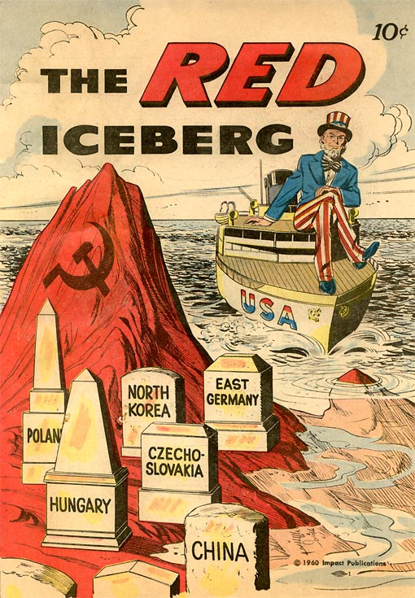
What were the motives [ambitions/desires/aims] of the US and USSR during the Cold War?

Use at least three documents to take a stand on an issue (thesis). Use evidence from the documents to explain and support your claim.

__________________________________________________________________________________________

__________________________________________________________________________________________

__________________________________________________________________________________________

__________________________________________________________________________________________

__________________________________________________________________________________________

__________________________________________________________________________________________

__________________________________________________________________________________________

__________________________________________________________________________________________

__________________________________________________________________________________________

__________________________________________________________________________________________

__________________________________________________________________________________________

__________________________________________________________________________________________

__________________________________________________________________________________________

__________________________________________________________________________________________

__________________________________________________________________________________________

__________________________________________________________________________________________

__________________________________________________________________________________________

__________________________________________________________________________________________

__________________________________________________________________________________________

__________________________________________________________________________________________

__________________________________________________________________________________________

__________________________________________________________________________________________

