Name: ________________
UNIT 5: 20th Century Crises – Genocide TOPIC: Analyzing Multiple Sources (DBQ)

2 | 3 | 4
Attempts to use more than one document on the same topic to take a stand on an issue (thesis). Evidence used from the sources to explain and support the position (claim) may have some misconceptions or inaccuracies. | Uses at least three documents on the same topic to take a stand on an issue (thesis). Accurately uses evidence from three or more sources to explain and support the position (claim). | In addition to meeting the level 3 expectation, the response includes prior knowledge or outside information to enhance the position and recognizes and responds to the opposing viewpoint (counter claim).

Can the world resolve the problem of genocide?

Use the questions below to help you analyze documents A-F.

- What is the central idea of the document? (What’s this all about?)

- What evidence from the document can you use to support the central idea?

- How does this document fit into the historical context? (How does it fit into our unit of study?)

- What’s the author’s opinion on the subject?

- Will this document support your claim? If so, how? If not, why not?

Document A

Document B
Document C

Document D

Document E

Document F

Can the world resolve the problem of genocide?

Use at least three documents to take a stand on an issue (thesis). Use evidence from the documents to explain and support your claim.

__________________________________________________________________________________________

__________________________________________________________________________________________

__________________________________________________________________________________________

__________________________________________________________________________________________

__________________________________________________________________________________________

__________________________________________________________________________________________

__________________________________________________________________________________________

__________________________________________________________________________________________

__________________________________________________________________________________________

__________________________________________________________________________________________

__________________________________________________________________________________________

__________________________________________________________________________________________

__________________________________________________________________________________________

__________________________________________________________________________________________

__________________________________________________________________________________________

__________________________________________________________________________________________

__________________________________________________________________________________________

__________________________________________________________________________________________

__________________________________________________________________________________________

__________________________________________________________________________________________

__________________________________________________________________________________________

__________________________________________________________________________________________
Name: ________________

UNIT 5: 20th Century Crises – Conflict TOPIC: Analyzing Multiple Sources (DBQ)

2 | 3 | 4
Attempts to use more than one document on the same topic to take a stand on an issue (thesis). Evidence used from the sources to explain and support the position (claim) may have some misconceptions or inaccuracies. | Uses at least three documents on the same topic to take a stand on an issue (thesis). Accurately uses evidence from three or more sources to explain and support the position (claim). | In addition to meeting the level 3 expectation, the response includes prior knowledge or outside information to enhance the position and recognizes and responds to the opposing viewpoint (counter claim).

Which side has a more valid claim to the land known as Palestine/Israel?
Historical Context: In 1947, the United Nations drew up a plan dividing Palestine into two states, Jewish and Arab, which the Arabs rejected. The next year, Israel was established as an independent nation according to the United Nations guidelines. As a result of the 1967 war, Israel gained control of the West Bank and Gaza Strip. Gaza was unilaterally given to the Palestinians in 2005. Palestinians still do not have an independent state of their own. Despite ongoing conflict between the Israelis and Palestinians, many on both sides still hope for peace.
Use the questions below to help you analyze documents A-G.

- What is the central idea of the document? (What’s this all about?)

- What evidence from the document can you use to support the central idea?

- How does this document fit into the historical context? (How does it fit into our unit of study?)

- What’s the author’s opinion on the subject?

- Will this document support your claim? If so, how? If not, why not?

Document A - The Balfour Declaration: November 2, 1917

During the First World War, British policy became gradually committed to the idea of establishing a Jewish home in Palestine (Eretz Yisrael). After discussions in the British Cabinet, and consultation with Zionist leaders, the decision was made known in the form of a letter by Arthur James Lord Balfour to Lord Rothschild. The letter represents the first political recognition of Zionist aims by a Great Power.

Foreign Office
November 2, 1917
Dear Lord Rothschild,
I have much pleasure in conveying to you, on behalf of His Majesty's Government, the following declaration of sympathy with Jewish Zionist aspirations which has been submitted to, and approved by, the Cabinet.
"His Majesty's Government view with favour the establishment in Palestine of a national home for the Jewish people, and will use their best endeavours to facilitate the achievement of this object, it being clearly understood that nothing shall be done which may prejudice the civil and religious rights of existing non-Jewish communities in Palestine, or the rights and political status enjoyed by Jews in any other country."
I should be grateful if you would bring this declaration to the knowledge of the Zionist Federation.
Yours sincerely, Arthur James Balfour

Document B – “The Zionist Case” by Golda Meir (an excerpt from a speech given on March 25, 1946)

“As I have said, we came to Palestine to do away with the helplessness of the Jewish people through our own endeavors. Therefore, you will realize what it meant for us to watch from here millions of Jews being slaughtered during these years of war . . . We Jews only want that which is given naturally to all peoples of the world to be masters of our own fate . . . We are certain that given an opportunity of bringing in large masses of Jews into this country, of opening the doors of Palestine to all Jews who wish to come here, we can . . . create a free Jewish society built on the basis of cooperation, equality and mutual aid.”

Document C – Nihaya Qawasmi’s “Children of a Tenth-Class God?” (an excerpt)

“Late at night when everything is quiet I think about how I will ever forgive the Israelis for what they did to me. I don’t mean stealing my homeland, killing my people, turning me into a refugee, or depriving me from having a Palestinian state. I’m talking about myself – what they did to my personality. I wish I had a normal life: no tension, no rage, no hatred, no hard feelings toward anybody. Even if they leave my country and give me back my rights, how will I overcome these feelings inside me?”

Document D – Map of Palestinian Loss of Land from 1946 to 2000

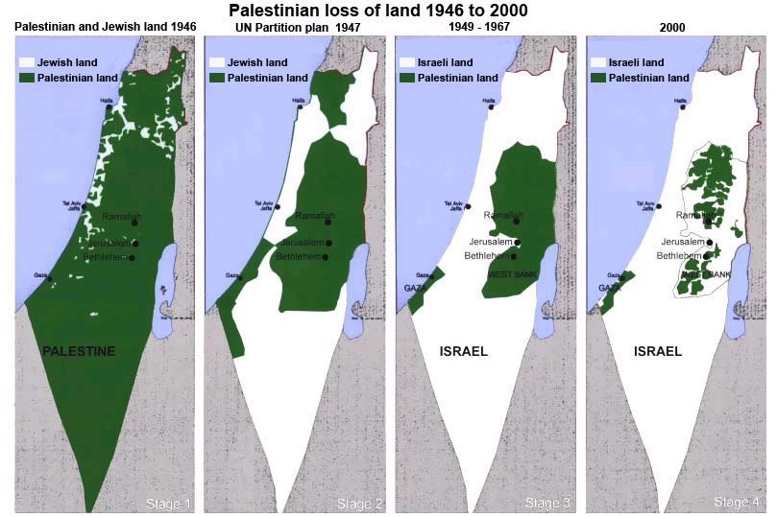

Document E – President Jimmy Carter, 39th President of the United States, speaking about his book Palestine: Peace Not Apartheid

. . . I used maps, text and documents to describe the situation accurately and to analyze the only possible path to peace: Israelis and Palestinians living side by side within their own internationally recognized boundaries. These options are consistent with key U.N. resolutions . . .

(My) book describes the abominable oppression and persecution in the occupied Palestinian territories, with a rigid system of required passes and strict segregation between Palestine's citizens and Jewish settlers in the West Bank. An enormous imprisonment wall is now under construction, snaking through what is left of Palestine to encompass more and more land for Israeli settlers . . .

I have made it clear that the motivation is not racism but the desire of a minority of Israelis to confiscate and colonize choice sites in Palestine, and then to forcefully suppress any objections from the displaced citizens. Obviously, I condemn any acts of terrorism or violence against innocent civilians, and I present information about the terrible casualties on both sides.

Document F – “A Palestinian View”

"These people have walked off with our home and homeland, with our movable and immovable property, with our land, our farms, our shops, our public buildings, our paved roads, our cards, our theaters, our clubs, our parks, our furniture, our tricycles. They hounded us out of ancestral patrimony (land) and shoved us in refugee camps . . . Now they were astride the whole of historic Palestine and then some.”
–Fawaz Turkei, quoted in the Arab-Israeli Conflict

Document G – “An Israeli View”

"Since the establishment of the State of Israel, its national security policy has been designed to defend its existence, integrity, and security, and not for expansionist territorial aspirations. Hence, if Arab confrontation states did not initiate wars against Israel or pose threats to its existence, then Israel would not start a war . . . to extend its territories . . . Our national security policy created from its very beginning the linkage between Israel’s political willingness for peace and Israel’s military capability repel aggression of any kind and scale.”
–Abraham Tamir, quoted in From War to Peace

Which side has a more valid claim to the land known as Palestine/Israel?
Use at least three documents to take a stand on an issue (thesis). Use evidence from the documents to explain and support your claim.

__________________________________________________________________________________________

__________________________________________________________________________________________

__________________________________________________________________________________________

__________________________________________________________________________________________

__________________________________________________________________________________________

__________________________________________________________________________________________

__________________________________________________________________________________________

__________________________________________________________________________________________

__________________________________________________________________________________________

__________________________________________________________________________________________

__________________________________________________________________________________________

__________________________________________________________________________________________

__________________________________________________________________________________________

__________________________________________________________________________________________

__________________________________________________________________________________________

__________________________________________________________________________________________

__________________________________________________________________________________________

__________________________________________________________________________________________

__________________________________________________________________________________________

__________________________________________________________________________________________

__________________________________________________________________________________________

__________________________________________________________________________________________

