TOPIC: USING INFORMATION FROM SOURCES
Name: ________________

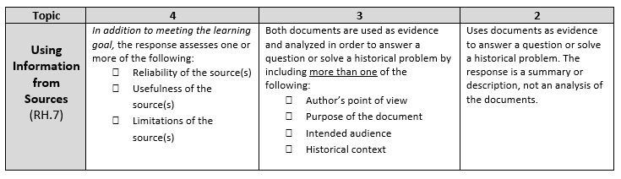

Historical Context:
For some Americans, imperialist expansion was a moral duty and necessary for America to achieve maturity as a nation. For other Americans, imperialist expansion was dangerous, immoral, and racist.

Directions:
The question below is based on accompanying documents. The documents have been edited for the purpose of this exercise.

In your response you should do the following:

- Make a claim to answer the question.
- Support the claim with evidence from at least three of the documents.
- Incorporate analysis of at least three of the documents. Focus your analysis on at least one of the following: intended audience, purpose, historical context, or author’s point of view.

Based on the following documents and your understanding of this time period, take a position, either in support of or opposition to, American imperialism.

Document 1

“We earnestly condemn the policy of the present national administration in the Philippines. It seeks to extinguish the spirit of 1776 in those islands. We deplore the sacrifice of our soldiers and sailors, whose bravery deserves admiration even in an unjust war. We denounce the slaughter of the Filipinos as a needless horror. We protest against the extension of American sovereignty by Spanish Methods . . .

We hold with Abraham Lincoln, that “no man is good enough to govern another man without that other’s consent. When the white man governs himself, that is self-government, but when he governs himself and also governs another man, that is more than self-government-that is despotism (rule by tyrant).”

*Note: A platform is a series of positions or beliefs that a group or political party fights for.

Source: Platform of the American Anti-Imperialist League, October 1899.

Document 2

The opposition tells us that we ought not to govern people without their consent. I answer, “The rule… that all just government derives its authority from the consent of the governed, applies only to those who are capable of self-government. We govern the Indians without their consent, we govern our territories without their consent, we govern our children without their consent . . . Would not the people of the Philippines prefer the just, human, civilizing government of this Republic to the savage, bloody (Spanish) rule . . . from which we have rescued them? . . .

. . . Do we owe no duty to the world? Shall we turn these peoples back to the reeking hands from which we have taken them? Shall we abandon them with Germany, England, Japan hungering for them? . . .
Wonderfully has God guided us . . . We cannot retreat from any soil where Providence has unfurled our banner; it is ours to save . . . for liberty and civilization.”

Source: Albert J. Beveridge, “The March of the Flag.” Campaign speech while running for the US Senate in Indiana, September 16, 1898.

Document 3

What is our title to the Philippine Islands? . . . When we made allies of the Filipinos and armed them to fight against Spain, we disputed Spain’s title . . . There can be no doubt that . . . we had full knowledge that they were fighting for their own independence . . .

Some argue that American rule in the Philippine Islands will result in the better education of the Filipinos. Be not deceived . . .(We) dare not educate them lest they learn to read the Declaration of Independence and the Constitution of the United States and mock us for our inconsistency.

. . . (A) war of conquest is as unwise as it is unrighteous . . . It is not necessary to own people in order to trade with them . . . Imperialism finds no warrant in the Bible. The command, “Go ye into all the world and preach the gospel to every creature,” has no Gatling gun attachment . . .

*Note: In 1900 Bryan was the Democratic Party’s candidate for president and gave this speech at the Democratic National Convention. He ran against William McKinley, the Republican candidate.

Source: William Jennings Bryan, speech, “Paralyzing Influence of Imperialism,” August 8, 1900.

Document 4

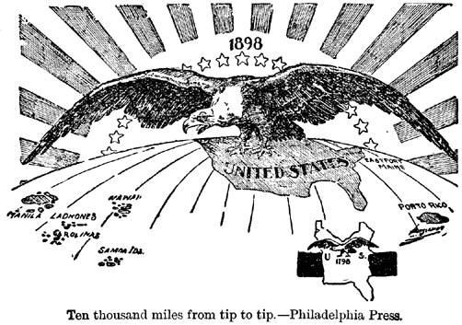

Document 5

I walked the floor of the White House night after night until midnight; and I am not ashamed to tell you, gentlemen, that I went down on my knees and prayed (to) Almighty God for light and guidance more than one night. And one night late it came to me this way-I don’t know how it was but it came:

(1) that we could not give (the Philippines) back to Spain-that would be cowardly and dishonorable;
(2) that we could not turn them over to France and Germany-our commercial rivals in the Orient-that would be bad business and discreditable;
(3) that we could not leave them to themselves-they were unfit for self-government-and that they would soon have anarchy and misrule over there worse than Spain’s was;
and
(4) that there was nothing left for us to do but take them all, and to educate the Filipinos, and uplift and civilize and Christianize them, and by God’s grace do the very best we could by them, as our fellowmen for whom Christ also died.

And then I went to bed, and went to sleep and slept soundly.

Source: William McKinley, speech to a group of clergymen, November 21, 1899. In James Rusling, “Interview with President William McKinley,” Christian Advocate, January 22, 1903.

Document 6
