TOPIC: USING INFORMATION FROM SOURCES
Name: ________________

Topic | 4 | 3 | 2
Using Information from Sources  (RH.7) | In addition to meeting the learning goal, the response assesses one or more of the following:  - Reliability of the source(s)  - Usefulness of the source(s)  - Limitations of the source(s) | Both documents are used as evidence and analyzed in order to answer a question or solve a historical problem by including more than one of the following:  - Author’s point of view  - Purpose of the document  - Intended audience  - Historical context | Uses documents as evidence to answer a question or solve a historical problem. The response is a summary or description, not an analysis of the documents.

Use the historical documents to explain who was responsible for the Boston Massacre.

Document 1

Source: “The Bloody Massacre Perpetrated in King Street,” engraving published by the Patriot, Paul Revere in 1770.
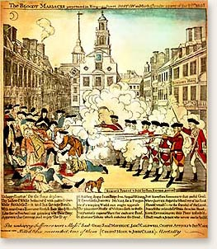

Document 2
Source: Captain Preston’s account of the Boston Massacre, 1770.
“[The crowd] immediately surrounded the sentry posted there, and with clubs and other weapons threatened to execute their vengeance on him. I was soon informed by a townsman their intention was to carry off the soldier from his post and probably murder him…. They advanced to the points of the bayonets, struck some of them and even the muzzles of the pieces, and seemed to be endeavoring to close with the soldiers... While I was thus speaking, one of the soldiers having received a severe blow with a stick, stepped a little on one side and instantly fired….”

