TOPIC: USING INFORMATION FROM SOURCES
Name: ________________

Topic | 4 | 3 | 2
Using Information from Sources  (RH.7) | In addition to meeting the learning goal, the response assesses one or more of the following:  - Reliability of the source(s)  - Usefulness of the source(s)  - Limitations of the source(s) | Both documents are used as evidence and analyzed in order to answer a question or solve a historical problem by including more than one of the following:  - Author’s point of view  - Purpose of the document  - Intended audience  - Historical context | Uses documents as evidence to answer a question or solve a historical problem. The response is a summary or description, not an analysis of the documents.

Use the historical documents to support or refute the following statement:

Americans were justified in migrating west.

Document 1

Source: American Progress, an 1872 painting by John Gast depicting American migration west.

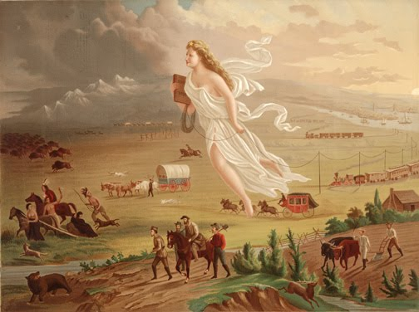

Document 2
Source: Treaty Between the United States and the French Republic, the treaty that ceded the Louisiana Territory from France to the United States, April, 1803.

Article III
The inhabitants of the ceded territory shall be incorporated in the Union of the United States and admitted as soon as possible according to the principles of the federal Constitution to the enjoyment of all these rights, advantages and immunities of citizens of the United States, and in the mean time they shall be maintained and protected in the free enjoyment of their liberty, property and the Religion which they profess.

