TOPIC: USING INFORMATION FROM SOURCES
Name: ________________

Topic | 4 | 3 | 2
Using Information from Sources  (RH.7) | In addition to meeting the learning goal, the response assesses one or more of the following:  - Reliability of the source(s)  - Usefulness of the source(s)  - Limitations of the source(s) | Both documents are used as evidence and analyzed in order to answer a question or solve a historical problem by including more than one of the following:  - Author’s point of view  - Purpose of the document  - Intended audience  - Historical context | Uses documents as evidence to answer a question or solve a historical problem. The response is a summary or description, not an analysis of the documents.

Using the historical documents, support, refute, or modify the following statement:
African Americans were free during Reconstruction.

Document 1

Source: The 13th and 14th amendments to the United States Constitution are sometimes called the “Reconstruction Amendments.” They were passed in order to abolish slavery and to establish the rights of former slaves.

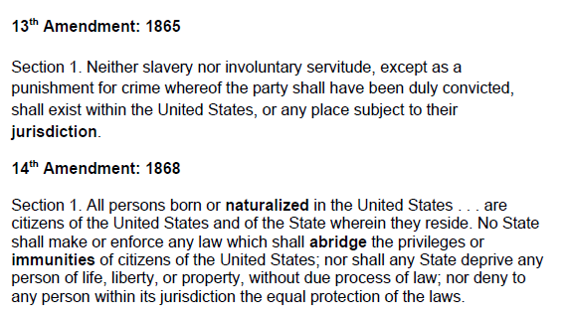

Document 2

Source: Former slaver Henry Adams made this statement before the Senate in 1880 about the early days of his freedom after the Civil War.

